Ella Mae (Lehman) Sprunger
May 18, 1927 – January 22, 2016

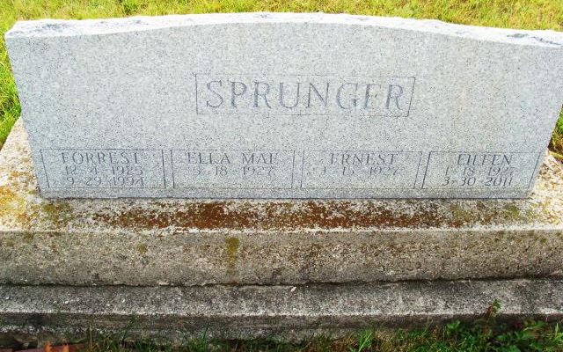
Photo by Alicia Kneuss

Ella Mae Sprunger, 88, Berne, passed away Friday, January 22, 2016 at Swiss Village where she was a resident since 2007. She was born on May 18, 1927 to John and Ida Garber Lehman in Versailles. MO. She married Forrest W. Sprunger on February 28, 1947.
Ella Mae was a member of the First Mennonite Church since moving to Berne, and was a member of the Mennonite Choral Society. In addition to be a loving and dedicated wife, mother, and grandmother, she was employed as a cook at South Adams Schools and later, a nurses aid at Swiss Village Retirement Center. Ella was a member of the Farm Bureau Pet and Hobby Club and enjoyed participating in 4-H with her children. She also worked alongside Forrest and daughter, Barbara as a custodian at South Adams. In recent years Ella Mae was a Stephen Minister in the Stephen Ministry of First Mennonite Church. Involvement in this ministry was life giving for her in recent years before she moved to Swiss Village.
Survivors include sons, JW (Deborah Coffin) Sprunger of Lancaster, PA., Norman J.D. Sprunger of Berne, James (Carolyn Cable) Sprunger of Goshen, daughter Barbara Jayne Sprunger of Berne. Ella Mae has 4 grandchildren who she loved very much and prayed for diligently. They are Nathan, Rachel, Matthew (Amanda Bogucki) Sprunger and Lance Sprunger.
Preceding in death are her parents, husband Forrest, sisters; Nadine Jelleff, Melva Lehman, Viola Kimble, Clara Lehman, Bertha Ault, and brothers, Albert, Wilbert, and Peter Lehman.
Funeral services are Friday, January 29, 2016 at 10:30 am at Swiss Village Chapel with visitation 1 hour prior to services. Visitation also Thursday from 4 to 8 pm in the chapel. Officiating is Pastor Jerry A. Flueckiger. Burial is in the MRE Cemetery, Berne.
Preferred memorials are to the First Mennonite Church &/or Gideons International

Yager-Kirchhofer Funeral Home, Adams County, Indiana
January 24, 2016

