Ella E. (Sprunger) Sprunger
July 7, 1893 – July 13, 1966

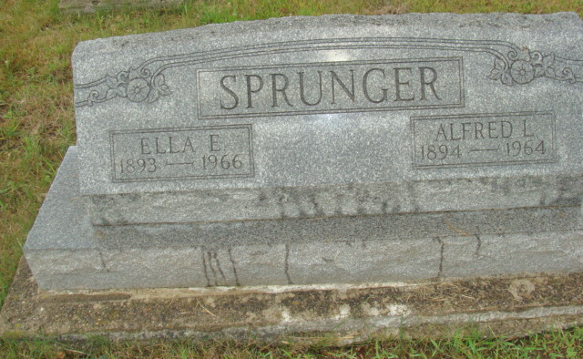
Photo by Alicia Kneuss
Ella Sprunger, Widow of Alfred Sprunger, 73, Succumbs Here
Dies at Berne Nursing Home Wednesday Evening
Mrs. Alfred (Ella) Sprunger, 73, passed away Wednesday evening at 9:30, at the Berne Nursing Home where she had been a resident for the past four years. She was in failing health at the time she entered the home and has been in declining health since that time. Death was attributed to complications. Her chief ailments were hardening of the arteries and Parkinson’s disease.
Mrs. Sprunger was a native of Berne but was a resident of Fort Wayne for more than forty years. She was a resident of that city at the time she entered the nursing home here. Born in Berne on July 7, 1893, she was a daughter of Abraham and Magdalena Neuenschwander Sprunger. She was married on June 25, 1922 to Alfred (Fred) Sprunger who preceded her in death in 1964.
Surviving are two daughters, Mrs. Albert (Norma Jean) Fujishiro, of Honolulu, Hawaii, presently in Ellensburg, Washington, at Central Washington State College, and Mrs. Nelson (Ladonna) Chamberlin, of Corydon, Ind., and one sister, Mrs. Amalia Baumgartner of Berne. Miss Jennie Miller, of Fort Wayne, is a foster sister.
An infant son and the following brothers and sisters preceded her in death: Levi A Sprunger, Mrs. Burkhart (Lydia) Lehman, Samuel A. Sprunger, Mrs. David F. (Emma) Lehman who were half-brothers and half-sisters; Mrs. Edwin H. (Mary) Gilliom, Albert N. Sprunger, Alfred A. Sprunger, Hiram A. Sprunger, a sister and brother in childhood.
Mrs. Sprunger grew up as a member of the First Mennonite church here. In Fort Wayne she became a member of the First Missionary church where she held membership at the time of death.
Friends may call at the Yager Funeral Home after 2 p.m. Saturday. Services will be held at the funeral home at 2:30 p.m. Sunday with Rev. Cornelius Vlot, pastor of the First Missionary church, Fort Wayne, and Rev. Gerald Stucky, associate pastor of the First Mennonite church here, officiating. Burial will be in MRE Cemetery.

Yager Funeral Home
July 14, 1966

