Elizabeth (Lehman) Sprunger
November 17, 1867 – February 11, 1909

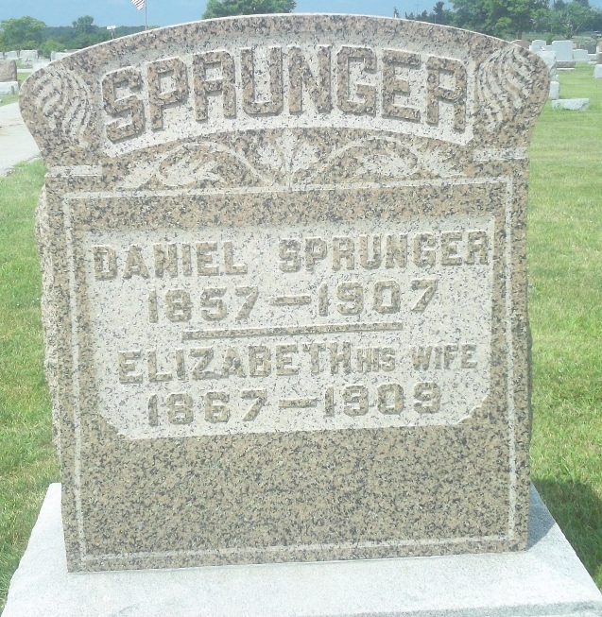
Photo by DSON1492
Indiana, U.S., WPA Death Index, 1882-1920
Name Elizabeth Sprunger
Date Feb 11, 1909
Location Berne
Age 41 Yr
Gender Female
Race White
Source location County Health Office, Decatur
Source notes The source of this record is the book H-13 on page 78 within the series produced by the Indiana Works Progress Administration.
**

Indiana, U.S., Marriages, 1810-2001

Name Elizabeth C Lahman
Gender Female
Race White
Event Type Marriage Registration (Marriage)
Birth Place Adams
Marriage Date 6 Dec 1889
Marriage Place Berne, Indiana, United States
Residence Place Berne, Indiana
Father Christian B Lahman
Mother Anna Spounger
Spouse Jacob J Stuckey
Page 266
**

Indiana, U.S., Marriage Index, 1800-1941

Name Elizabeth Stuckey
Marriage Date 12 Jan 1896
Marriage Place Adams, Indiana, USA
Spouse Name Daniel Sprunger
**

Elizabeth C Lehman from tree Christopher_2012-07-07
Birth 17 Nov 1867 Berne, Adams, Indiana, USA
Marriage 12 Jan 1896 Berne, Adams, Indiana, USA
Residence 1900 Adams, Indiana, USA
Death 11 Feb 1909 Berne, Adams, Indiana, USA
Father Christian B Lehmann (1821-1892)
Mother Anna Maria Sprunger (1826-1879)
Spouse Jacob J Stuckey (1866-1894); Daniel Sprunger (1857-1907)
7584 People 10 Records 15 Sources

