Elizabeth A. (Habegger) Sprunger
November 22, 1859 – June 21, 1900

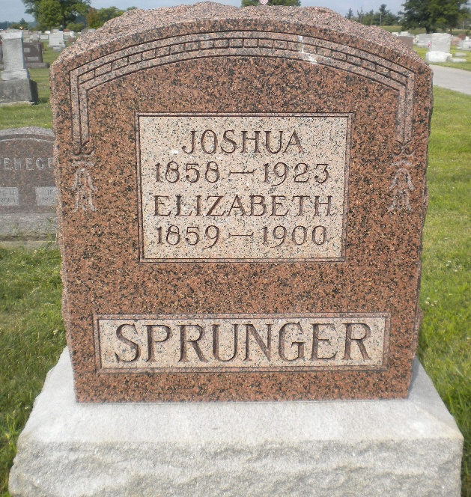
Photo by DSON1402
Eliza Sprunger
in the Indiana, U.S., Death Certificates, 1899-2011
Name: Eliza Sprunger
[Eliza Hebegger]
Gender: Female
Race: White
Age: 40 years, 6 months, 30 days
Marital status: Married
Birth Date: abt 1860
Birth Place: Switzerland Europe
Death Date: 21 Jun 1900
Death Place: Monroe, Adams, Indiana, USA
Father: Peter Hebegger
Mother: Eliza Lehman
Informant: A. Sprunger; Berne, Indiana
Burial: June 22, 1900; MRE Cemetery

