Eliza Sprunger
June 20, 1880 – June 15, 1896

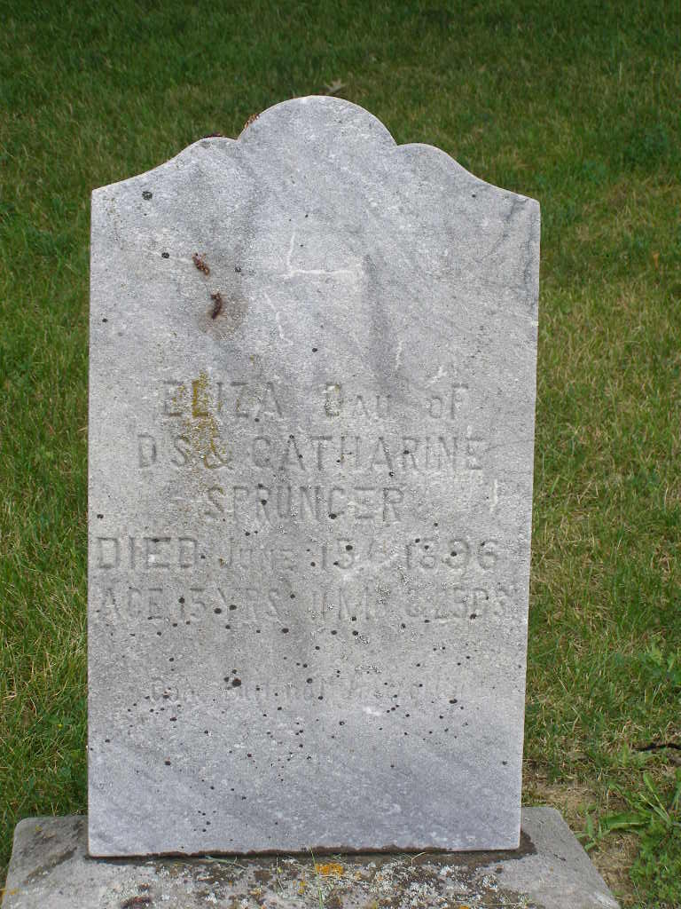
Photo by Shaunda Bedwell Opdycke

Elisa S. Sprunger from tree Seifert Family Tree

Birth 20 Jun 1880 Berne, Adams, Indiana, USA
Death 15 Jun 1896
Father David S Sprunger (1856-1926)
Mother Katharina S Lehman (1857-1938)
342 People 0 Records 5 Sources

