Eli Simon Sprunger
April 22, 1918 – April 11, 2011

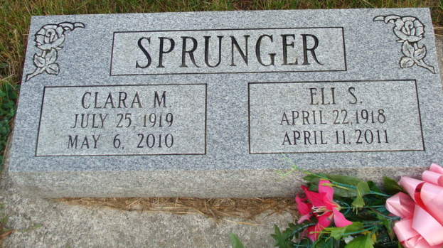
Photo by Alicia Kneuss

Eli S. Sprunger, 92, a resident of Berne, Indiana passed away at 9:45 a.m. Monday, April 11, 2011 at the Swiss Village Retirement Community in Berne, Indiana. Eli was born on April 22, 1918 in Adams County, Indiana the son of Emil and Matilda (Hirschy) Sprunger, both deceased. He married Audrey Crosby and she preceded him in death. He then married Clara Steury Matchett and she preceded him in death in 2010.
Eli was a member of the First Missionary Church in Berne. He was a Swiss Craftsman formerly employed at Dunbar Furniture, Berne Furniture, and Smith Brothers Furniture as a master wood finisher. He later was self employed at Sprunger Refinishing Shop. Eli enjoyed golf, fishing, and was an avid New York Yankees fan.
Eli is survived by a son, Randall (Sara) Sprunger of Berne; a daughter, Sharon Cook of Decatur, Indiana; a daughter, Pat (Evan) Liechty of Chardon, Ohio; a brother, Leroy Sprunger of Berne; a brother, Tilman Sprunger of Berne; and a sister, Miriam Sprunger of Fort Wayne, Indiana. Other survivors include thirteen grandchildren, twenty-six great-grandchildren, and three great-great-grandchildren.
Eli was preceded in death by brothers; Norman Sprunger, Raymond Sprunger, Melvin Sprunger, and Clifford Sprunger, and sisters; Minnie Basinger, Inez Patterson, Esther Biberstein, and Edith Minger.
Funeral services will be held at 10:30 a.m. Thursday, April 14, 2011 at the First Missionary Church with the Pastor Kris McPherson officiating. Interment will be in the M.R.E. Cemetery of rural Berne.
Family and friends will be received from 2:00 – 8:00 p.m. Wednesday, April 13, 2011 at the Swiss Village Chapel and one hour prior to the funeral service at the church on Thursday.
Preferred memorials are to Family Hospice of Northeast Indiana.

Zwick & Jahn Funeral Homes, Adams County Indiana

