Eli Sprunger
January 21, 1863 – April 8, 1941

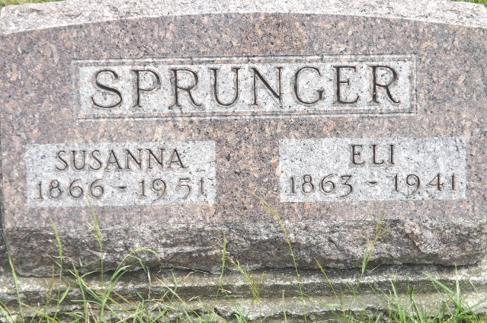
Photo by Jim Allen

ELI SPRUNGER DIES SUDDENLY
Former Prominent Decatur Resident Dies At Bluffton Home

Eli Sprunger, 78, for many years a resident of Decatur, died suddenly at 11:30 o'clock Tuesday night at his home, 412 East Market street, in Bluffton. His wife, overcome by shock, fainted and was unable to summon aid until after 2 o'clock this morning.
Mr. Sprunger for many years was an importer of Belgian horses, and was recognized as one of the leading stockmen of the middle west. He served several years as a judge at the international livestock exposition at Chicago.
He was born in Wells county January 21, 1863, the son of Abraham and Katherine Moser-Sprunger. He married Susan Riesen in Berne in 1888. He was a member of the Mennonite church at Berne.
Surviving besides the widow are a daughter, Mrs. Harry Starr of Bluffton; a son, Leo Sprunger of Saginaw, Mich.; three sos [sic] (should be brothers) Lewis and Amos Sprunger of Berne and Abraham of Fort Wayne, and two sisters, Mrs. J. D. WInteregg, of Berne and Mrs. Gideon Badertscher of Fort Wayne. A sister, Mrs. Jacob Steiner, died Saturday afternoon.
Funeral services will be held at 3 o'clock Friday afternoon at the Thoma funeral chapel in Bluffton, Rev. Matthew Worthman officiating. Burial will be in the M.R.E. cemetery at Berne.

Adams County, Indiana Historical Museum
1940-1941a Scrapbook, image 44
Handwritten date: Wednesday, April 9, 1941
**

The death of Eli Sprunger, 78, at his home in Bluffton, brings sorrow to many people in Adams county and Decatur who remember him as an outstanding citizen here for many years. He was recognized as one of the outstanding stockmen of the middle west, served as a judge of horses for the International Stock Show (Cut off)

Adams County, Indiana Historical Museum
1940-1941a Scrapbook, image 44
Handwritten date: Thursday, April 10, 1941
**

Indiana, Death Certificates, 1899-2011

Name: Eli Sprunger
Gender: Male
Race: White
Age: 78
Marital Status: Married
wife: Susan Reisen
Birth Date: 21 Jan 1863
Birth Place: Wells Co Indiana
Death Date: 8 Apr 1941
Death Place: Bluffton, Wells, Indiana, USA
Father: Abraham Sprunger b. Switzerland
Mother: Katherine Sprunger b. Wells Co, IN
Informant: Mrs. Harry Starr of Bluffton, IN
Burial: MRE on 4/11/1941

