Eileen R. (Sprunger) Sprunger
January 18, 1927 – March 30, 2011

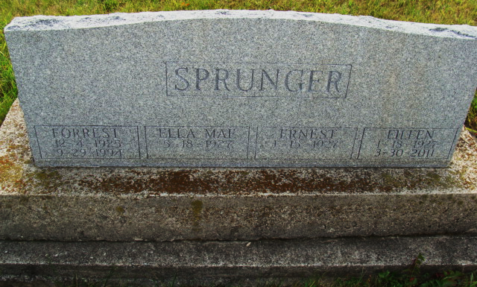
Photo by Alicia Kneuss

Eileen Sprunger, 84, a resident of Berne, Indiana passed away at 2:09 p.m. Wednesday, March 30, 2011 at the Adams Memorial Hospital in Decatur, Indiana. Eileen was born on January 18, 1927 in Adams County, Indiana the daughter of Marcus and Clara (Nichols) Sprunger, both deceased. She married Ernest Sprunger on September 10, 1950 and he survives.
Eileen was a member of the First Mennonite Church in Berne. She was a former employee of the Berne Ben Franklin Store. Eileen enjoyed baking and gardening. Eileen is survived by her husband Ernest Sprunger of Berne; a son, Dale (Sue) Sprunger of Berne; a son, Tom Sprunger of Berne; a son, Mark Sprunger of Berne; a daughter, Wendy (Tod) Striker of Berne; a daughter, Becky (Steven) Billington of Bryant; a step sister, Anna Jane Fennig of Berne; and a step-brother, Glenn Habegger of Tucson, Arizona. Other survivors include six grandchildren and one great-grandchild.
Eileen was preceded in death by her parents; her step-mother, Barbara Habegger Sprunger; a sister, Marcella Liechty; a step-sister, Donna Mae Habegger; and a brother, Merlin Habegger.
Funeral services will be held at 10:30 a.m. Saturday, April 2, 2011 at the First Mennonite Church with the Pastor Jeff Linthicum officiating. Interment will be in the M.R.E. Cemetery of rural Berne. Family and friends will be received from 2:00 – 8:00 p.m. Friday, April 01, 2011 at the Yager-Kirchhofer Funeral Home in Berne and one hour prior to the funeral service at the church on Saturday.
Preferred memorials are to Gideons International.

Yager-Kirchhofer Funeral Home, Adams County, Indiana

