Edward A. Sprunger
January 16, 1920 – October 24, 1997

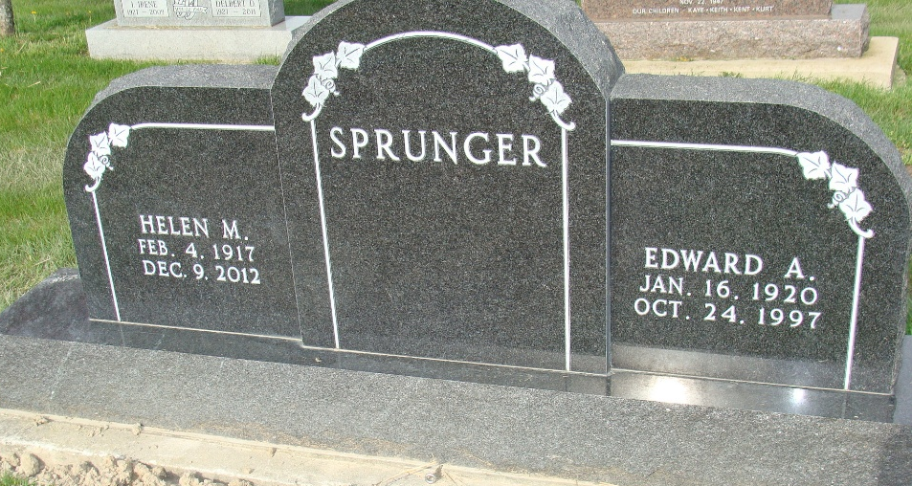
Photo by Alicia Kneuss
EDWARD A. SPRUNGER, 77, died Friday at Adams County Memorial Hospital. He retired as part-owner of Berne Hi-Way Hatchery and was former president of Berne Lions Club. Surviving are his wife, Helen; three daughters, Beth Jones of Berne, Candy Schierling of Fort Wayne and Barbara McDonald of Berne; six grandchildren; and nine great-grandchildren.
Services at 2 p.m. Sunday at First Mennonite Church, Berne. Calling from 1 to 9 p.m. today and from 11 a.m. to noon Sunday at Yager-Kirchhofer Funeral Home, Berne. Calling also an hour before services at the church. Burial in M.R.E. Cemetery, Berne. Memorials to the church or to donor's choice.
Journal Gazette, The (Allen County, Indiana)
Saturday, October 25, 1997
**
Indiana, U.S., Death Certificates, 1899-2017
Name Edward A Sprunger
Gender Male
Race White
Marital Status Married
Age 77
Birth Date 16 Jan 1920
Birth Place Adams County
Death Date 24 Oct 1997
Death Place Decatur, Adams, Indiana, USA
Death Registration Date 1997
Father Adolph Sprunger
Mother Esther Sprunger
Spouse Helen (Balsiger) Sprunger, informant
Burial 10/26/1997 M.R.E.

