Edward Sprunger
1899 - 1903

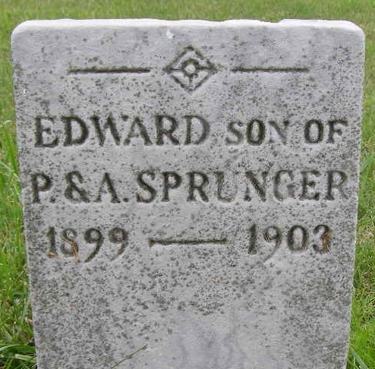
Photo by Shaunda Bedwell Opdycke

Indiana, U.S., Death Certificates, 1899-2017

Name Edward Sprenger
Gender Male
Race White
Age 4y 0m 17d
Birth Date 13 Feb 1899
Birth Place Berne Indiana
Death Date 3 Mar 1903
Death Place Berne, Adams, Indiana, USA
Death Registration Date 1903
Father Philip Sprunger, informant
Mother Emma Lehman
Burial M.R.E. Cemetery 3/5/1902
**

Edward Sprunger from tree Mum's Family

Birth 13 Feb 1899 Monroe City, Adams, Indiana, USA
Residence 1900 Monroe City, Adams, Indiana, USA
Death 3 Mar 1903 Indiana, USA
Father Philip Sprunger (1858-1934)
Mother Anna Lehman (1859-1927)
9024 People 5 Records 6 Sources

