Edna (Neaderhouser) Sprunger
December 16, 1897 – July 5, 1970

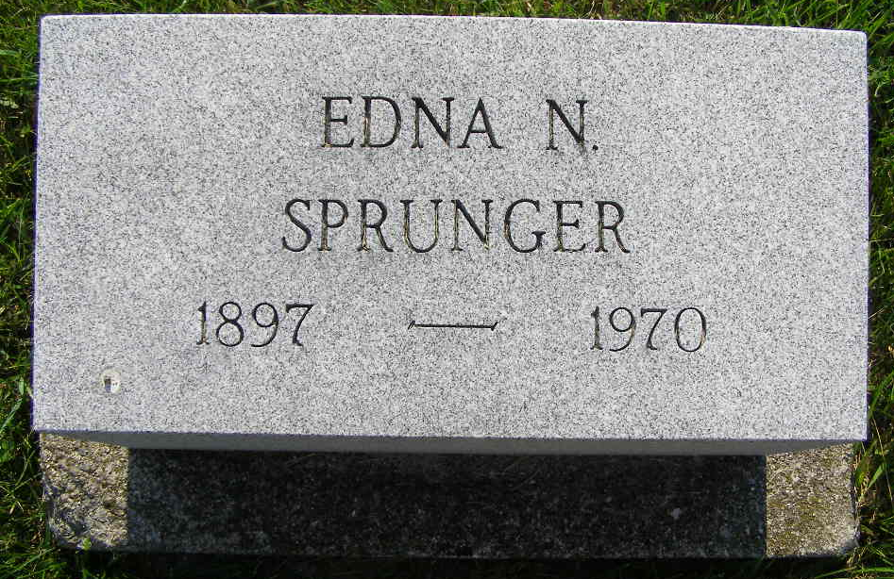
Photo by Shaunda Bedwell Opdycke

Berne native dies Sunday in Illinois
Mrs. Edna Sprunger, 72, of Champaign, Ill., a native of Berne and a former school teacher, died at 10 a.m. Sunday at Bernham City Hospital in Champaign. She taught school in Berne, Breman and at Harrison Hill in Fort Wayne from 1924 to 1953.
Born in Berne Dec. 16, 1897, she was a daughter of Fred and Mary Lehman-Neaderhouser. She was married to Milton F. Sprunger, June 14, 1953, when she moved to Elmhurst, Ill., then to Champaign in 1964. Mrs. Sprunger was a member of the First Presbyterian Church at Champaign.
Surviving is her husband; a stepdaughter, Mrs. Bonnie Wood of San Francisco, Calif.; two sisters, Miss Flora and Miss Elma Neaderhouser, both of Fort Wayne; and two step-children.
Services will be held at 10 a.m. Tuesday at the Middendorfer Funeral Home in Champaign. The body will be brought to the Yager Funeral Home in Berne, where friends may call from 7 to 9 p.m. Tuesday. Graveside services will be held at 10 a.m. Wednesday at the MRE Cemetery.
Decatur Daily Democrat, Adams County, Indiana
Monday, July 6, 1970
**
Mrs. Edna N. Sprunger, Champaign, Ill., a former Fort Wayne resident and teacher died at 10:15 am yesterday in Bernham City Hospital, Champaign, where she had been a patient two months.
A native of Berne, she resided in Fort Wayne from 1924 to 1953 and taught at Harrison Hill Junior High School. In 1953, she moved to Elmhurst, Ill., where she resided 11 years and then moved to Champaign. She was a member of First Presbyterian Church, Champaign.
Surviving are her husband, Milton F.; two sisters, Miss Elma and Flora Neaderhouser, Fort Wayne; a stepdaughter, Mrs. Bonnie Wood, Lafayette, Calif.; and two step grandchildren.
Services will be at 10 am Tuesday in Mittendorfer Funeral Home, Champaign. Burial will be at 10 am Wednesday in MRE Cemetery, Berne.

Date of Death: July 5, 1970; Date of Burial: July 8, 1970
Burial: Lot 224, Original Platt
Berne (IN) Public Library Heritage Room
1969 – 1972 Obits

