Edmund Sprunger
February 17, 1884 – February 17, 1854

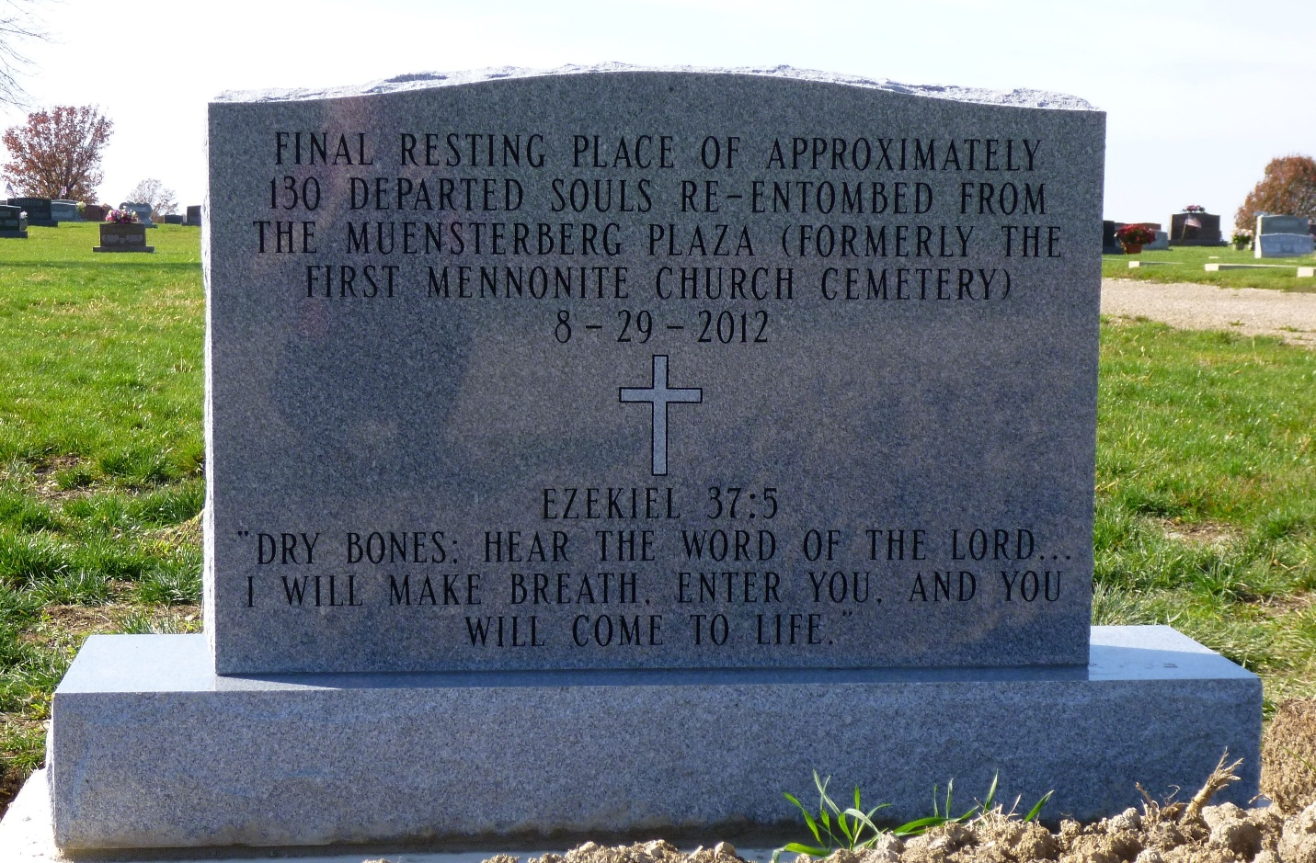
Photo by Max haines

The bodies of those buried in the old Meunsterberg Cemetery, Berne, IN were moved to MRE Cemetery. This stone marks their resting place. Emond was among those moved to this place in September 2012.

