Edgar P. Sprunger
August 17, 1917 – August 27, 2003

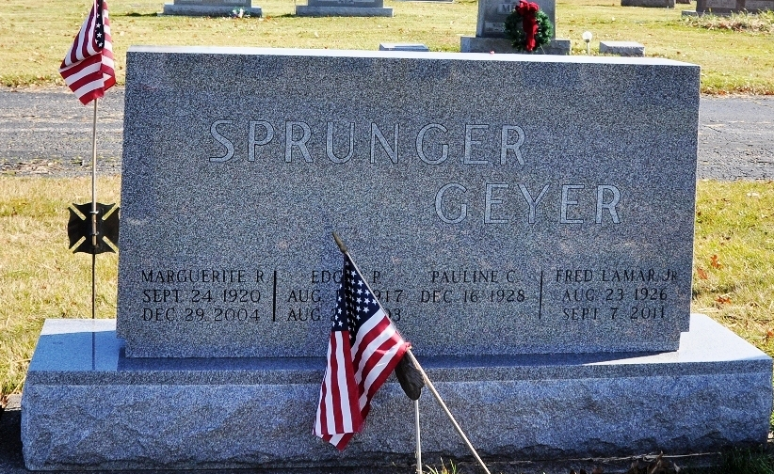
Photo by Deb Curry

A retired Berne dentist, Dr. Edgar P. Sprunger, 86, died Wednesday morning at Adams County Memorial Hospital following a one week illness. Born Aug. 17, 1917 in Adams County to Robert L. and Rhoda Liechty Sprunger, he was united in marriage Nov. 24, 1948 to Marguerite Michaud, who survives.
A veteran of U.S. Army service as a captain, Dr. Sprunger served as a dentist from 1948 to 1982. He volunteered his dentistry skills as a missionary in Africa, served on the board of directors of the Fort Wayne Bible College, and was a former Rotary Club member. He graduated from Goshen College and Northwestern University School of Dentistry. Dr. Sprunger was a member of West Missionary Church in Berne and had served as a Sunday school teacher.
Surviving in addition to his wife are two sons, Patrick and Reed Sprunger, both of Fort Wayne; two daughters, Mrs. Rev. Barry (Andrea) McCune of Van Wert, Ohio, and Mrs. Jeff (Lisa) Nickel of Corn, Okla.; four brothers, Donald, Eugene, and Roy Sprunger, all of Berne, and Rev. Sam Sprunger of Hammond; a sister, Mrs. Dr. James (Betty) Gurley of Ann Arbor, Mich.; and eight grandchildren.
Two other brothers, Rev. John Sprunger and Robert Lavere Sprunger, preceded him in death.
Services are scheduled for Saturday at 10:30 a.m. at West Missionary Church under the direction of Rev. Keith Rupp. Burial will be in M.R.E. Cemetery west of Berne. Calling hours at Swiss Village Chapel are from 3-8 p.m. Friday and one hour prior to services Saturday at West Missionary Church.
Memorials may be made to Swiss Village, West Missionary Church or Gideons International. Arrangements are being made by Yager-Kirchhofer Funeral Home in Berne.

Bluffton News Banner, Wells County, Indiana
Aug. 28, 2003

