Dwight Edmund Sprunger
February 10, 1924 – March 24, 1982

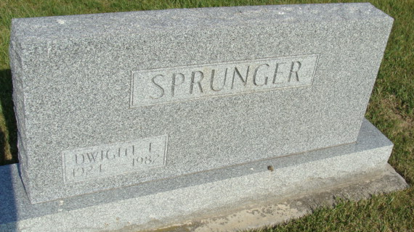
Photo by Alicia Kneuss

Dwight Edmund Sprunger from tree Helm & Lammert

Birth 10 Feb 1924 Berne, Adams, Indiana, USA
Residence 1 Apr 1940 Adams, Indiana, USA
Death 24 Mar 1982 Washington DC
Father Herman Edmund Sprunger (1902-1970)
Mother Arminda Hirschy (1901-1964)
20627 People 3 Records 5 Sources
**

U.S., World War II Draft Cards Young Men, 1940-1947

Name Dwight Edmund Sprunger
Gender Male
Race White
Age 18
Relationship to Draftee Self (Head)
Birth Date 10 Feb 1924
Birth Place Berne, Indiana
Residence Place Berne, Adams, Indiana, USA
Registration Date 30 Jun 1942
Registration Place Indiana, USA
Employer Herman Sprunger
Height 5 7; Weight 125
Complexion Light
Hair Color Brown; Eye Color Brown
Next of Kin Herman Sprunger

