Dorothy E. (Ball) Sprunger
September 23, 1923 – October 20, 2007

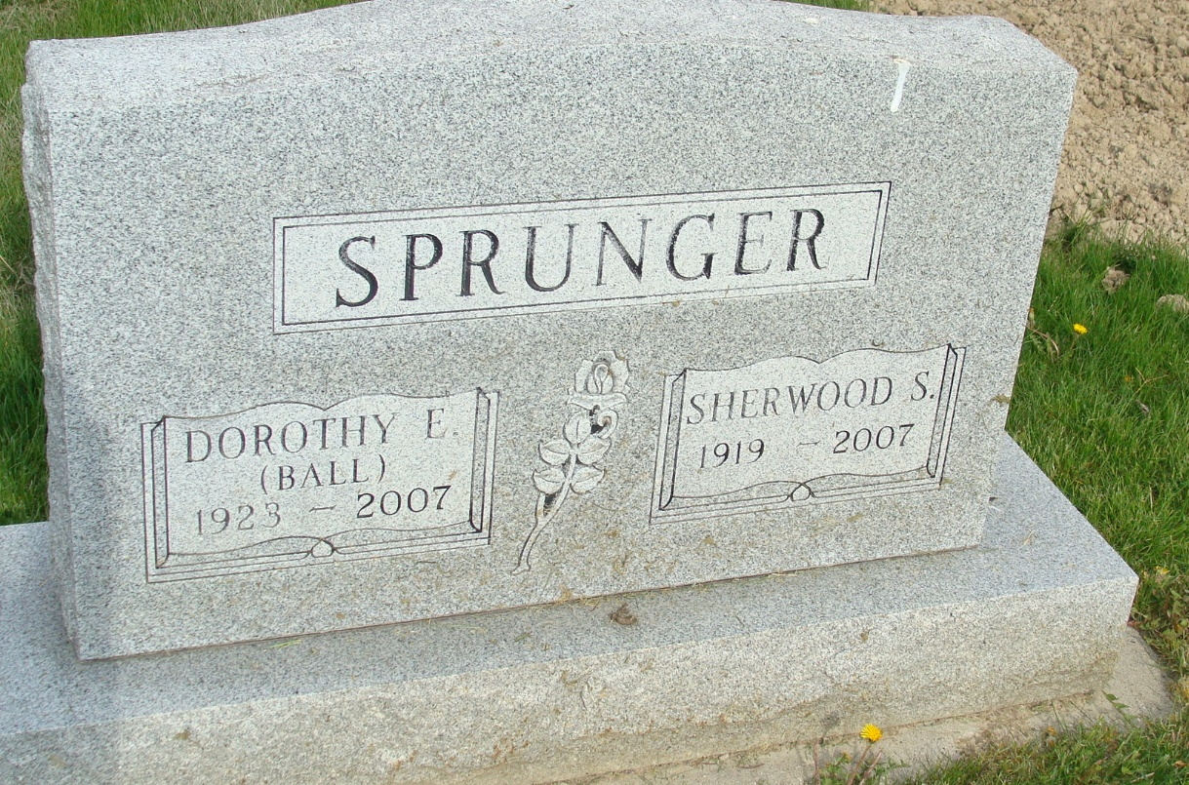
Photo by Alicia Kneuss

Dorothy Ball Sprunger, 84, a resident of Tallahassee, Florida, and a former Berne resident, died on Saturday, October 20, 2007 in Tallahassee. She was born on September 23, 1923, in Detroit, Michigan, to Henry M. and Virginia (Yontz) Ball. She was married on February 4, 1945 to Sherwood Sprunger.
There will be a 10:00 a.m. graveside service on Friday, November 2 at MRE Cemetery. Officiating is Rev. Dennis Schmidt. Yager-Kirchhofer Funeral Home is in charge of services.
Berne Tri-Weekly News, Adams County, Indiana
Wed., Oct 31, 2007

