Dorcas F. Sprunger
September 3, 1889 – April 18, 1959

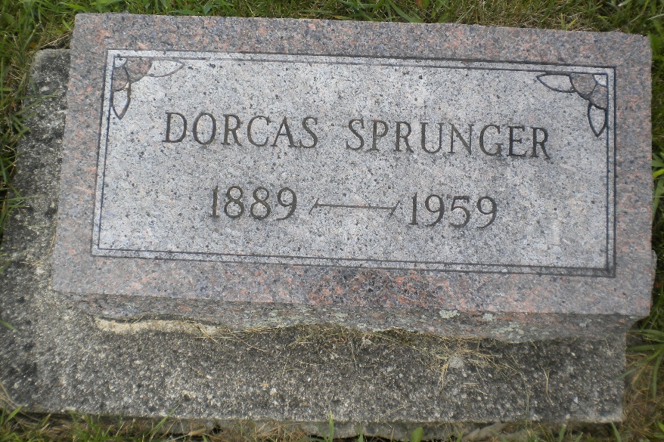
Photo by DSON1492

Indiana, U.S., Death Certificates, 1899-2017
Name Dorcas F. Sprunger
Gender Female
Race White
Marital Status Never Married (Single)
Age 69y 7m 15d
Birth Date 3 Sep 1889
Birth Place Berne, Indiana
Death Date 18 Apr 1959
Death Place Berne, Adams, Indiana, USA
Death Registration Date 1959
Father Samuel F. Sprunger
Mother Katherine Luginbill
Informant Eva Sprunger, sister
Burial 4-22-1959 MRE Cemetery

