Dora Sprunger
June 25, 1887 – January 13, 1966

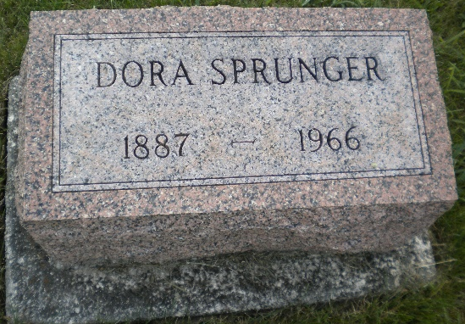
Photo by DSON1492

U.S., Family History Books

Name Theodora Sprunger
Death Place B-Monroe Twp., Ind. R-Berne, Ind
Father Ulrich Sprunger
Mother Anna Liechty
Title The Sprunger Family, Descendants of Peter Sprunger, Born 1757, Including His Male Ancestral Line to Hans Sprunger, Born 1565-1575
Author Herr, Willis Eldon
p. 149 4.7.5.1 Theodora Sprunger 6-25-1887 ~ 1-13-1966
b. Monroe Twp., Ind., R-Berne, Ind. worked in over-all factory and did housework.
**

Theodora Sprunger from tree Julie Frederick Family Tree

Birth 25 Jun 1887 Berne, Adams, Indiana, USA
Residence 1940 Berne, Adams, Indiana, USA
Death 13 Jan 1966
Father Ulrich Sprunger (1860-1932)
Mother Anna Liechty (1861-1945)
14139 People 3 Records 21 Sources

