Deloris June (Sprunger) Sprunger
September 12, 1927 – September 28, 2021

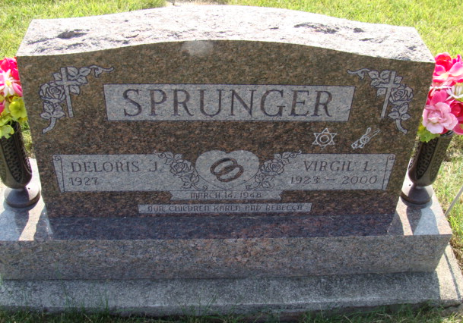
Photo by Alicia Kneuss

Deloris J. Sprunger, 94, of Bluffton, went to be with her Lord on Tuesday, September 28, 2021, at Swiss Village in Berne. She was born in Adams County, Indiana, on September 12, 1927, the daughter of the late Joel and Clara (Ellenberger) Sprunger. On March 14, 1948, she married Virgil Sprunger, he preceded her in death on September 27, 2000.
She worked at CTS in Berne for 25 years. Deloris was a member of Decatur Wesleyan Church, was active for years as the church treasurer, Sunday school teacher, pianist, and as well as Women’s Ministries. She was currently a member of Bluffton First Church of the Nazarene.
Deloris is survived by two daughters, Rebecca (Dennis) Behning of Markle, IN, Karen Kistler of Winterhaven, FL; seven grandchildren; 15 great-grandchildren; 1 great-great-grandson.
She was preceded in death by her husband of 52 years, Virgil Sprunger; three brothers, Arley, Merlin, and Kenneth Sprunger, a sister, LaVera Sprunger.
A Funeral Service will be held at 12:00 p.m. Tuesday, October 5, 2021, at Haggard-Sefton-Hirschy & Zelt Funeral Home. Rev. Joe Kelly will be officiating and burial will immediately follow in M.R.E. Cemetery. Visitation will be from 10:00 a.m. – 12:00 p.m. Tuesday, October 5, 2021, at Haggard-Sefton-Hirschy & Zelt Funeral Home.
Memorials may be made to Gideon’s International.

Haggard-Sefton-Hirschy & Zelt Funeral Home, Adams County, Indiana

