Della (Moser) Sprunger
May 29, 1886 – February 26, 1916

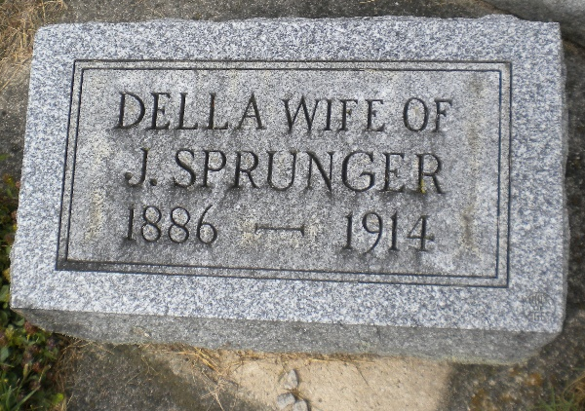
Photo by DSON1492

Biery – Yager Funeral Home Record, Adams County, Indiana
Nov. 5, 1910 – Dec. 28, 1916

Date: 2-26-1916
Name of deceased: Mrs. Jona Sprunger
Charge to: Mr. Jona Sprunger
Date of funeral: 2/28
Place of death: Berne
Funeral services at: Reformed 1:30-2:00
Clergyman: Rev. Kattman
Certifying physician: Reusser
Burial cert #: 15
Cause of death: Tuburlocos (sic)
Date of death: 2-26
Age: 29y 8m 27d
Interment: M.R.E.
**
Indiana, U.S., Death Certificates, 1899-2017
Name Della Sprunger (indexed as Sfrunger)
[Della Mosur]
Gender Female
Race White
Marital Status Married
Age 29y 8m 27d
Birth Date 29 May 1886
Birth Place Indiana
Death Date 26 Feb 1916
Death Place Berne, Adams, Indiana, USA
Death Registration Date 1916
Father John Moser
Mother Catherine Falb
Spouse Jonath Sprunger, informant
Burial MRE 2-28-1916

