Delbert D. Sprunger
September 1, 1927 – August 27, 2011

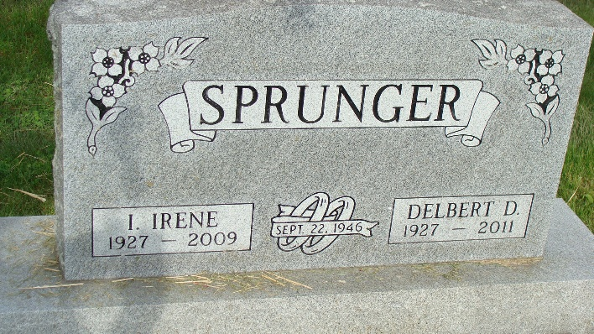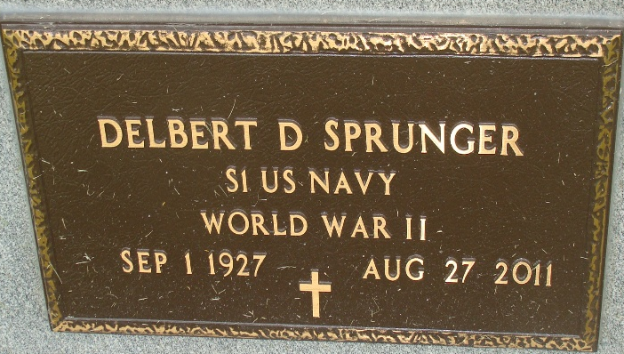
Photo by Alicia Kneuss

Delbert D. Sprunger, 83, Decatur, formerly of Berne, passed away Saturday, August 27, 2011 at the Adams Memorial Hospital He was born on September 1, 1927 in Adams County to Clarence and Lorine( Habegger) Sprunger. He married Ida Irene Zuercher on September 22, 1946 and she preceded him in death on April 11, 2009.
Delbert was a member of the First Mennonite Church, owned the Musik Haus for 30 years and also was widely known as a Piano Tuner Technician in a 50 mile area. He was a Veteran WW II serving in the U.S. Navy: was active in Community Affairs including President and Executive Manager of the Berne Chamber of Commerce: Boy Scout Troop Committee Chairman: President of the Mennonite Choral Society: President of the High School Music Boosters: & South Adams Arts Council. He was a member of the organizing Board for the Adams County Foundation and the Board for the Adams County United Way. He served on the Swiss Days committee for 15 years and Chairman of the committee for 3 years.
He is survived by a son, Erick Steven (wife, Mary Jane) of Sacramento, California. Brother, Logan Sprunger, Berne, and sister Donna Mae (Sam) Sprunger of Schereville, In. Preceded in death are his parents, 3 sisters, Jacqueline Burnett Smith, Jean Habegger, & Juanita Herman.
Memorial services are Saturday, September 3 at 11 am at the First Mennonite Church Chapel. Visitation Friday from 4 to 8 pm at the Yager-Kirchhofer Funeral Home. Officiating is Pastor Jerry Flueckiger. Burial in the MRE Cemetery.
Memorials are to First Mennonite Church, Berne CDC, & or/ the Salvation Army.

Yager-Kirchhofer Funeral Home, Adams County, Indiana

