DeLoris Wilma (Dailey) Sprunger
October 11, 1918 – October 3, 1996

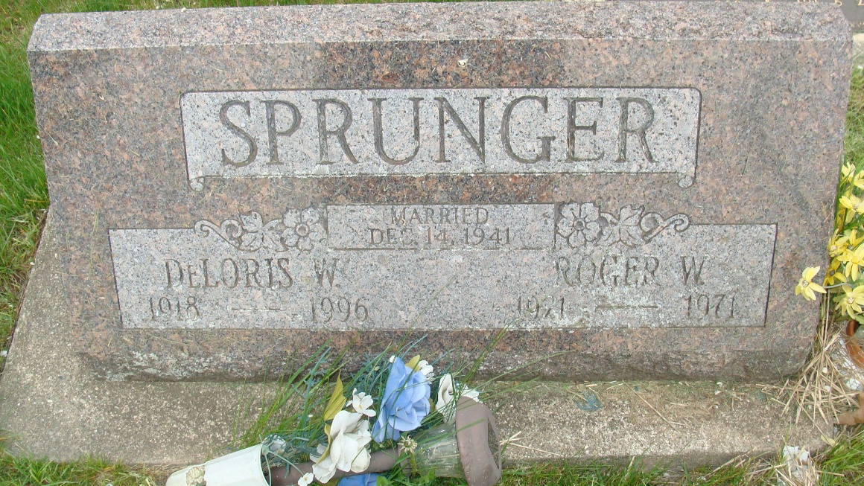
Photo by Alicia Kneuss

Indiana, U.S., Death Certificates, 1899-2017
Name Deloris Sprunger
[Deloris Dailey]
Gender Female
Race White
Marital Status Widowed
Age 77
Birth Date 11 Oct 1918
Birth Place Adams County
Death Date 3 Oct 1996
Death Place Decatur, Adams, Indiana, USA
Death Registration Date 1996
Father Herbert Dailey
Mother Eathel Evans
Informant Richard Sprunger, son
Burial 10/5/1996 M.R.E.

