David William Sprunger
December 22, 1924 – September 24, 2002

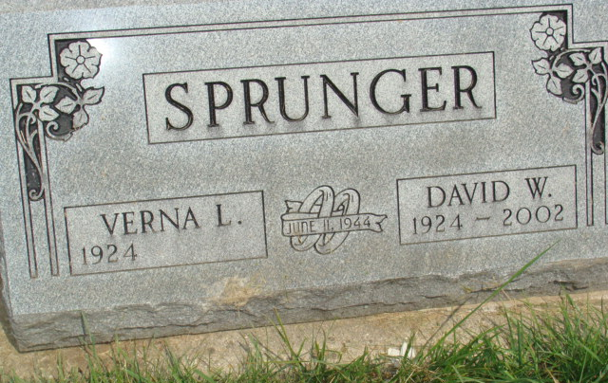
Photo by Alicia Kneuss

David W. Sprunger, 77, of Berne, who delivered motor homes for Dan Ray Driv-a-way in Decatur, died Tuesday, Sept. 24, 2002, at home. The Adams County native was retired from L & H Carbide Co. in Fort Wayne after 13 years of service, and had worked for Home Dairy and Indiana State Highway Department. He was a member of First Mennonite Church. Surviving are his wife, Verna; daughters Ruth Bixler of Decatur, Twyla and Jean Sprunger, both of Berne, and Judie Frolick of Convoy, Ohio; a son, Rick of Berne; sisters Laura Kirchhofer and Naomi Von Gunten, both of Berne; and seven grandchildren. He was preceded in death by two sisters. Services are 10:30 a.m. Friday at First Mennonite Church, Berne, with calling one hour before services. Calling is also from 2 to 8 p.m. Thursday at Yager-Kirchhofer Funeral Home, Berne. Burial will be at MRE Cemetery, Berne. Memorials are to Family Hospice of Northeast Indiana or the church MCC Meat Canner.
News-Sentinel, The (Allen County, Indiana)
Wednesday, September 25, 2002

