David N. Sprunger
May 16, 1855 – July 8, 1919

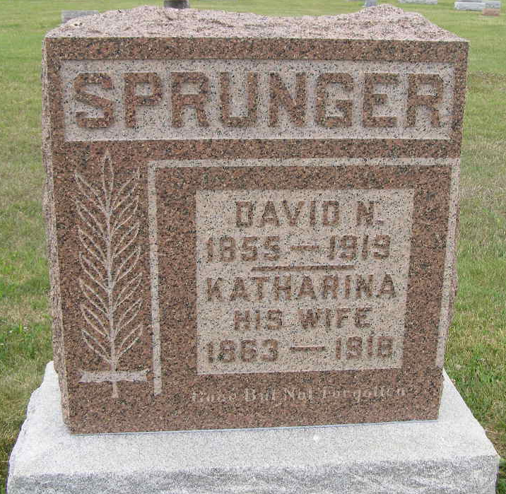
Photo by Shaunda Bedwell Opdycke

U.S., Family History Books

Name David N Sprunger
Gender Male
Birth Place Sonnbewalberg, Switzerland
Marriage Date 10 Mar 1888
Father Peter R
Mother Anna Reusser
Spouse Katharina Nussbaum
Child Joel Sprunger, Ludwig Sprunger, Katharina Nussbaum
Title The Sprunger Family, Descendants of Peter Sprunger, Born 1757, Including His Male Ancestral Line to Hans Sprunger, Born 1565-1575
Author Herr, Willis Eldon, p. 82
3/7/1 David N. Sprunger (5/16/1855 - 7/8/1919
David was born in Sonnbewalberg, Switzerland & was married on March 10, 1888 to Katharina Nussbaum, daughter of David. In the fall of 1889 they moved to America and established their home near Berne, Ind. They were farmers.

