David Sprunger
April 20, 1896 – April 7, 1977

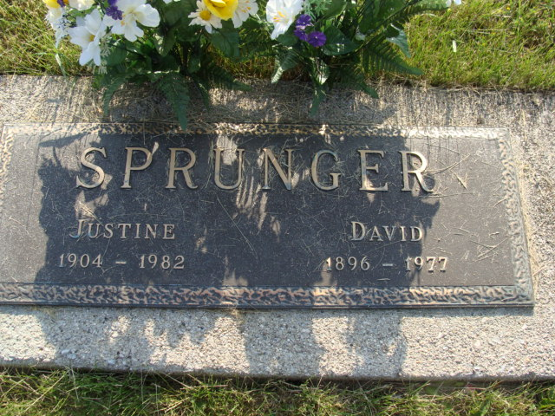
Photo by Alicia Kneuss

Services will be held Saturday at the Elzey Dickey Funeral Home for Funerals in Wayne for David Sprunger, 80, Fort Wayne, who died Thursday in Lutheran Hospital, Wayne
Rev. Allen Byrne, pastor of Waynedale United Methodist Church, which Mr. Sprunger was a member will officiate and burial will be in the M.R.E. Cemetery, Berne. Friends may call at the funeral home from 2 to 5 and 7 to 9 p.m. Friday.
Mr. Sprunger resided in ?? the past 23 years and was employed at the Shambaugh Heating & Cooling Firm. He was born near Berne, the son of Joshua and Anna Habegger Sprunger. He was married to Justine Lynn, January ?? in Louisville , Ky.
Surviving are the wife; two daughters; Mrs. David (Elizabeth) ?? Wayne and Mrs. Tho?? Phillips, Jamestown; ???grandchildren and a sister, Mrs. ???(Viola) Gilliom, Berne. Preferred memorials to the Waynedale United Methodist Memorial Fund. (Right side cut off-)
Berne (IN) Library Heritage Room
1973-1984 MRE Obit Book, image #148
**
Indiana, U.S., Death Certificates, 1899-2017
Name David Sprunger
Gender Male
Race White
Marital Status Married
Age 80
Birth Date 20 Apr 1896
Birth Place Indiana
Death Date 7 Apr 1977
Death Place Fort Wayne, Allen, Indiana, USA
Death Registration Date 1977
Father Joshua Sprunger
Mother Elizabeth Habegger
Spouse Justine (Linn) Sprunger, informant
Burial M*R*E* Cemetery 4-9-1977

