David Sprunger
July 25, 1826 – December 25, 1916

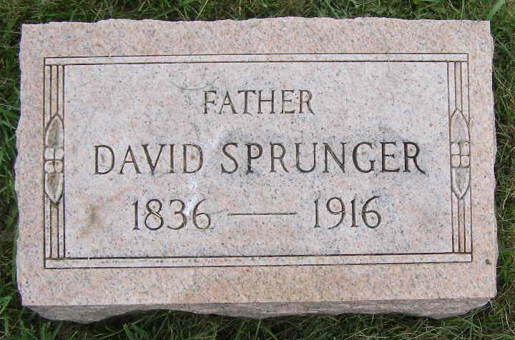
Photo by Shaunda Bedwell Opdycke

Biery-Yager Funeral Home Record, Adams County, Indiana
David Sprunger; Died December 25, 1916 at home; Age 80 years, 5 months; Widowed; Retired farmer; Mennonite; Funeral December 28, 1916 at Mennonite Church; Burial MRE Cemetery; Charge to David Sprunger estate; Order given by children.
**

David was born in Tavannes, Switzerland on July 5, 1836 to Johannes Sprunger and Anna Barbara Lehman (daughter of Johann & Barbara Lehman). He emigrated to America with his parents and several siblings in March 1852.
On January 1, 1857 he married Barbara Lehman, daughter of Johann Lehman from Wayne Co., Ohio. They moved from Ohio to Adams Co., Indiana and lived near Berne, Indiana where they had eleven children. She died there on August 3, 1874.
On August 3, 1876 he married Regina Moser, daughter of Christian Moser. She was born May 12, 1847 and died July 19, 1908. They lived in Adams Co., Indiana where they had eight children. David was a farmer and forkmaker.

Unknown source

