Eileen Rose (Graber) Sprunger - Daugherty
November 10, 1929 – December 18, 2023

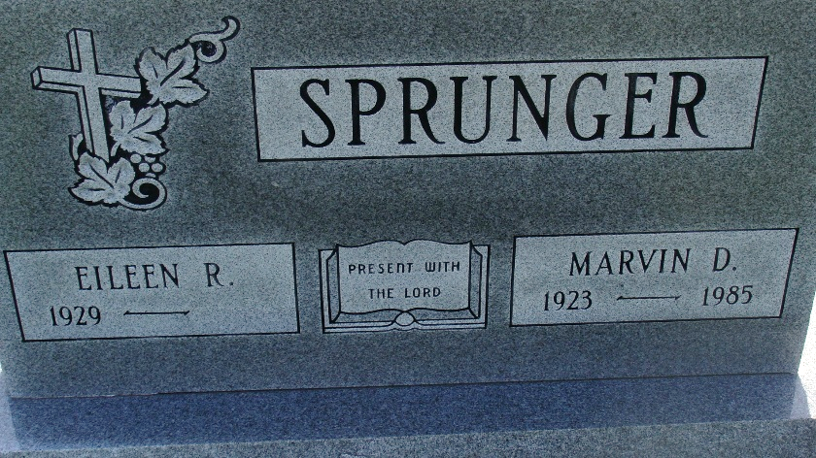
Photo by Alicia Kneuss

Eileen Rose (Graber) Sprunger Daugherty, 94, of Berne, Indiana, passed away Monday, December 18, 2023, at Swiss Village in Berne. She was born on November 10, 1929, to Henry P. and Adella (Habegger) Graber, at the home farm in Monroe Township, Adams County. She was born just after the stock market crash that began the Great Depression. Her family owned a farm north of Berne. She worked hard with her Dad in the fields during the summer, which instilled in her a strong work ethic. Fluent in Swiss Dialect, she did not speak English until she started first grade in the one-room school, north of Berne.
Eileen was the second oldest of the four siblings. In 1947, Eileen graduated second in her class from Monroe High School. In 1949, after dating one year, Eileen married the love of her life, Marvin Dale Sprunger. They were married on June 11, 1949, at the First Mennonite Church in Berne. Immediately after the wedding, Eileen and Marv set up house in Fayetteville, North Carolina where Marv was stationed at Ft. Bragg. Once discharged, they moved back to Berne and started Custom Floor & Wall, which they operated for 25 years until Marvin’s death in 1985.
Eileen and Marv had two daughters, Carol (1951) and Gloria (1953). Eileen was active in Mother’s Club in the 1950s. Eileen and Marv were founding members of Grace Bible Church in the 1960s. Eileen loved the Lord and taught Good News Club when the girls were young. She taught Sunday School and was church organist at Grace Bible Church for many years. She also served on the board of Evangelism Explosion, along with Marv, for several years.
Marvin passed away in August of 1985. One year later, Eileen sold Custom Floor & Wall and moved to Tulsa, Oklahoma to be near Gloria and her family. Eileen loved Tulsa and became active in the leadership of Bible Study Fellowship. She loved singing in the church choir at First United Methodist Church and her small group at Fellowship Bible Church, which became her church home.
In 1987, Eileen became the division secretary for Waddell & Reed Financial Services in Tulsa. She retired in 1997, after 10 years. Later in 1997, Eileen began volunteer work at Hillcrest Hospital in Tulsa and soon was hired by Hillcrest to work in the gift shop, which she loved. She stayed at Hillcrest for five years.
In 2001, Eileen met Bill Daugherty of Pennville, Indiana, and they were married in February 2002. She enjoyed traveling and accompanying The Christianaires, Bill’s Southern Gospel Quartet. Bill passed away in 2017, and once again, Eileen was widowed.
After a terrible farm accident in 2016, Eileen spent two months in Rehab at Swiss Village. In late 2016, Eileen and Bill moved to Swiss Village, where she lived until her passing. Upon moving back to Berne, Eileen once more became an active member of Grace Bible Church where she served as part-time organist. She loved her small group and especially her pastor and wife, Jeff and Becky Gaskill.
Eileen’s greatest joy was spending time with her children, grand-children, and great-grandchildren. They gave her such joy and she prayed for each individually every single day. Eileen was an avid reader, and music was her love language. She also mentored many people in her 94 years.
In addition to the loss of Marvin and Bill, Eileen was preceded in death by her parents, Henry and Adella Graber; step-mother Rachel Graber; sisters Evelyn Rich and Delores Moser; brother Don Graber; grandson Jeffrey Pyle; and son-in-law Sidney Sokolsky.
Eileen is survived by her two daughters, Carol (Allen) Pease of Tulsa, OK; Gloria (David) Newman of Tulsa, OK; stepsons, Ron Daugherty of Indianapolis, IN, and Don Daugherty of Plymouth, IN. Four grandchildren, Kavan Pyle of Pittsburgh, PA, Katie (Seymore) Shaw of Ft. Worth, TX, Natalie (David) Leonard of Thompson’s Station, TN, and Lindsey (Brian) Meek of Bixby, OK. Six great-grandchildren: Sydney and Journey Shaw, Ella Kate and River Leonard, Harper, and Hudson Meek. Also, sister-in-law Nancy Graber, and many nieces, nephews, and cousins.
A celebration of Eileen’s life will be held at 1:00 p.m. Monday, January 8, 2024, at the Swiss Village Chapel, 1350 W. Main St., Berne, Indiana. With visitation prior to the service, in the Swiss Village Chapel, from 10:00 to 11:00 a.m. Burial will follow at M.R.E. Cemetery in Berne, Indiana.
In lieu of flowers, memorials may be made to Grace Bible Church, Berne, Indiana, or Gideon’s International.

Zwick & Jahn Funeral Homes, Yager-Kirchhofer Chapel, Adams County, Indiana

