Daniel D. Sprunger
May 7, 1953 – February 27, 1992

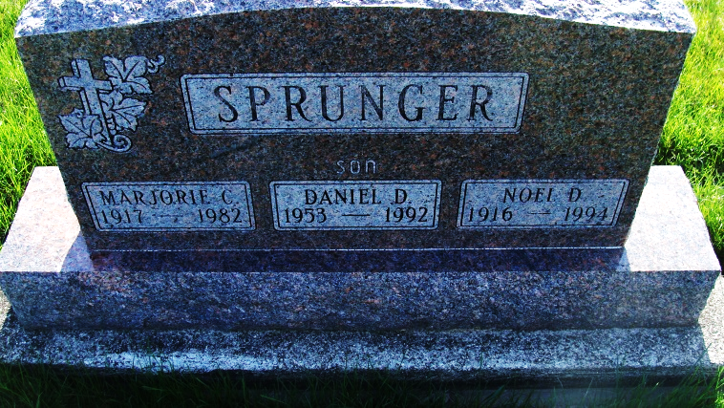
Photo by Alicia Kneuss

Daniel D. Sprunger, 38, died at 3:54 pm Thursday at Parkview Memorial Hospital from natural causes.
Surviving are his father, Noel of Berne; and a brother, Tom of Richardson, Texas.
Services at 2 pm Sunday at First Mennonite Church Chapel, Berne. Calling from 3 to 9 pm today and from 11 am to 12:30 pm Sunday at Yager-Kirchhofer Funeral Home, Berne and an hour before services at the church.
Burial in M.R.E. Cemetery, Berne. Memorials to the church or Gideon’s International.

Journal-Gazette, Allen County, Indiana
February 29, 1992, Page 5A
**

Indiana, U.S., Death Certificates, 1899-2017

Name Daniel D Sprunger
Gender Male
Race White
Marital Status Single
Age 38
Birth Date 7 May 1953
Birth Place Adams County, Indiana
Death Date 27 Feb 1992
Death Place Fort Wayne, Allen, Indiana, USA
Death Registration Date 1992
Father Noel Sprunger, informant
Mother Marjorie Baumgartner
Burial 3/1/1992 M.R.E.

