Daniel Sprunger
March 14, 1857 – November 25, 1907

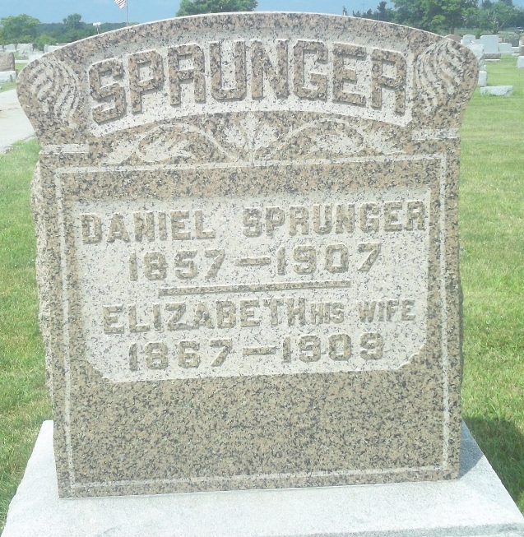
Photo by DSON1492
Indiana, U.S., Death Certificates, 1899-2017
Name Daniel Sprunger
Gender Male
Race White
Marital Status Married
Age 50y 8m 11d
Birth Date 14 Mar 1857
Birth Place Berne, Indiana
Death Date 25 Nov 1907
Death Place Berne, Adams, Indiana, USA
Death Registration Date 1907
Father Peter Sprunger b. Switzerland
Mother Mariana Moser b. Switzerland
Spouse Elisabeth Sprunger
Informant Sam Lehman, Berne, IN
Burial M.R.E. Cem. 11/27/1907

