Daniel John Sprunger
September 22, 1873 – December 6, 1945

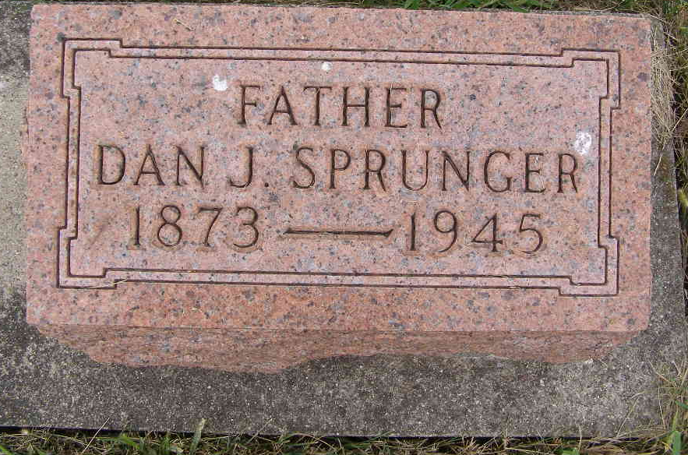
Photo by Shaunda Bedwell Opdycke

Indiana, U.S., Death Certificates, 1899-2017
Name D. J. Sprunger (indexed as Springer)
Gender Male
Race White
Marital Status Widowed
Age 72y 2m 14d
Birth Date 22 Sep 1873
Birth Place Berne, Adams County, Indiana
Death Date 6 Dec 1945
Death Place Berne, Adams, Indiana, USA
Death Registration Date 1945
Father Frederick Sprunger b. Switzerland
Mother Katherine Sprunger b. Wayne County, OH
Spouse Ella Reusser Sprunger
Informant Velma Sprunger, Berne, IN
Burial M.R.E. Cemetery 12/8/1945

