Corina Sprunger
April 27, 1900 – September 12, 1900

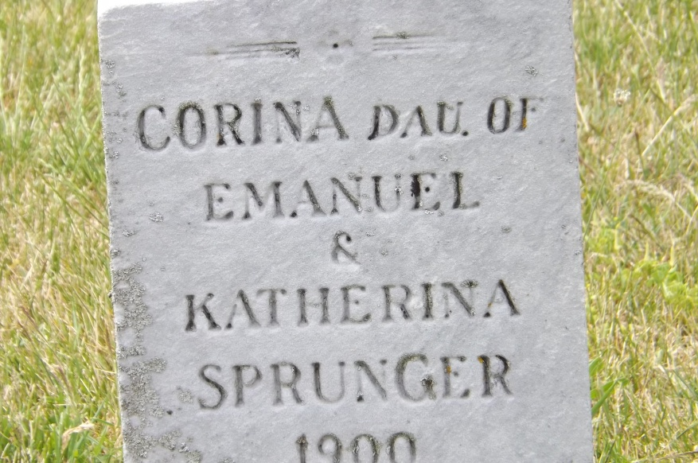
Photo by Jim Allen
U.S., Family History Books
Name Corina Sprunger
Title The Sprunger Family, Descendants of Peter Sprunger, Born 1757, Including His Male Ancestral Line to Hans Sprunger, Born 1565-1575
Author Herr, Willis Eldon, p. 189
5.1.3.9 Corina Sprunger 4-27-1900 9-12-1900
**
Corina Sprunger from tree Stauffer-McNutt Family Tree 1
Birth 27 Apr 1900 Monroe City, Adams, Indiana, USA
Death 12 Sep 1900 Monroe City, Adams, Indiana, USA
Father Emanuel Sprunger (1854-1936)
Mother Katherina "Katie" Stauffer (1861-1932)
202775 People 1 Record 4 Sources

