Cora (Mertz) Sprunger
October 5, 1892 – October 16, 1976

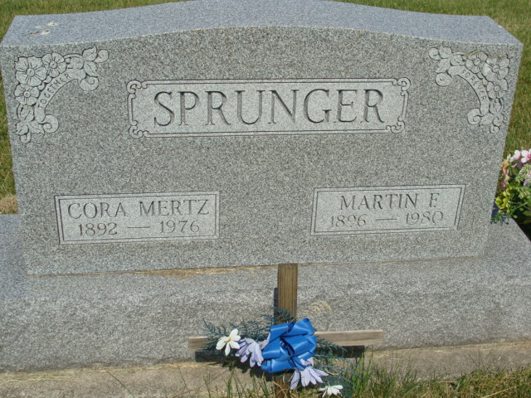
Photo by Alicia Kneuss

Indiana, U.S., Death Certificates, 1899-2017
Name Cora Sprunger
[Cora Mertz]
Gender Female
Race White
Marital Status Married
Age 84
Birth Date 5 Oct 1892
Birth Place Indiana
Death Date 16 Oct 1976
Death Place Decatur, Adams, Indiana, USA
Death Registration Date 1976
Father Andrew Mertz
Mother Elizabeth Amstutz
Spouse Martin F. Sprunger, informant
Burial M.R.E. Cemetery 10/19/1976

