Constance Marie Sprunger
February 7, 1950 – February 7, 1950

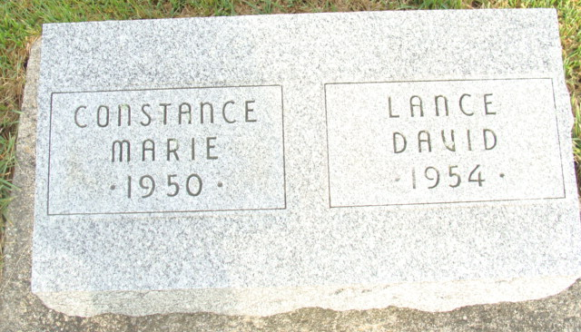
Photo by Alicia Kneuss

Indiana, U.S., Death Certificates, 1899-2017
Name Constance Marie Sprunger
Gender Female
Race White
Age 2 hours, premature
Birth Date 7 Feb 1950
Birth Place Berne, Indiana
Death Date 7 Feb 1950
Death Place Decatur, Adams, Indiana, USA
Death Registration Date 1950
Father Melvin Sprunger, informant
Mother Ethelyn Burnett
Burial 2-8-1950 M. R. E. Cemetery

