Clyde H. Sprunger
December 4, 1914 – November 30, 1995
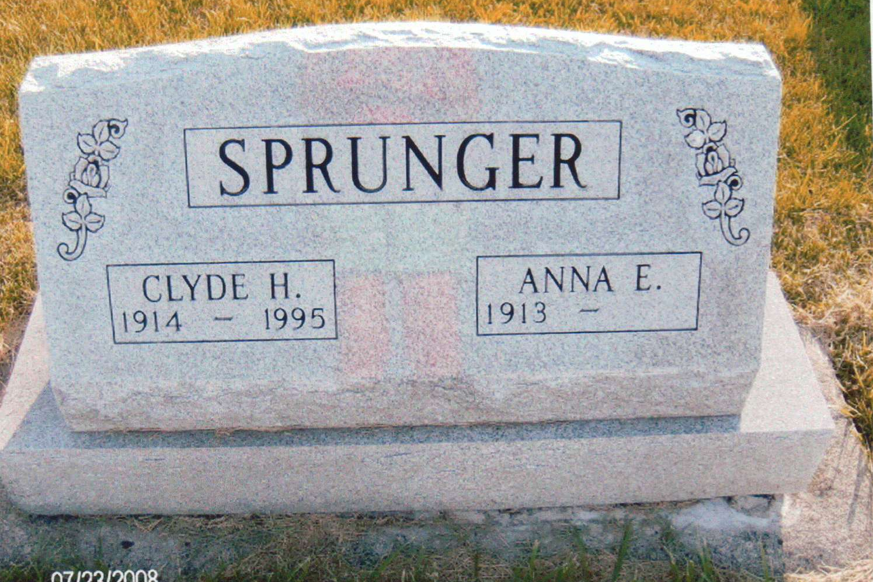
Photo by JC

Clyde H. Sprunger, 80, Swiss Village, Berne, died at 5:10 a.m. Thursday, November 30, 1995, at his residence following a week of illness of a stroke. He was born December 4, 1914 to Nathan and Caroline (Sheidegger) Sprunger. He married Anna Lehman on October 22, 1938, in Berne. She survives.
Mr. Sprunger retired from Moser ??? in Berne in December of 1977 after 44 years of experience as a mechanic and also as Assistant Service manager. He was a member of the ???Missionary Church, Berne, where he had been director of the ?? choir, a Sunday School teacher for many years, and chairman of the ???new building committee and ?? organ committee.
He was also a member of the Berne Lions Club and a veteran of World War 11 in the U.S. Navy. His favorite pastime was listening to vocal and instrumental music, and he performed Swiss yodeling at many area picnic functions.
Surviving in addition to his wife, ?? 2 sisters, Jeanette Sprunger, Berne, and Lila Miller, Camphill, Pennsylvania. He is preceded in death by his brothers and sisters, Rolland[sic], Clarence, Reuben, Dorothy Fuhrman, Leslie, Irvin, and Vincent.
Services will be at 10:30 a.m. Monday, December 4, in the First Missionary Church, Berne. Rev. Dennis Owens and Rev. Jonathan Amstutz will officiate. Burial will be in the M.R.E. Cemetery, Berne. Calling hours are 2 to 8 Sunday in the Yager-Kirchhofer Funeral Home, and Monday 1 hour prior to the services in the church. Memorials to church missions or Swiss Village.
(no date-Left side cut off)
Berne (IN) Library Heritage Room
Misc. Death Book BB, image 57

