Clinton H. Sprunger
May 8, 1898 – February 20, 1946

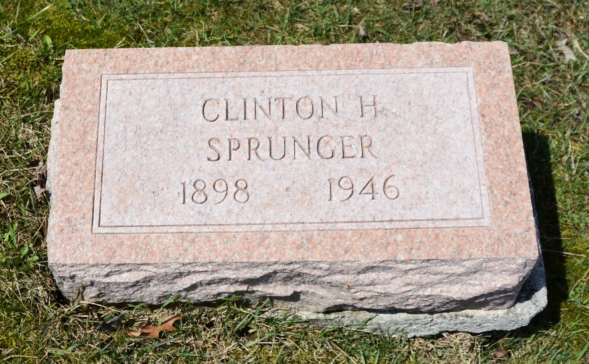
Photo by Deb Curry

Indiana, U.S., Death Certificates, 1899-2017
Name Clinton H Sprunger
Gender Male
Race White
Marital Status Single
Age 47y 7m 12d
Birth Date 8 May 1898
Birth Place Berne, Indiana
Death Date 20 Feb 1946
Death Place Fort Wayne, Allen, Indiana, USA
Death Registration Date 1946
Father Joshua Sprunger b. Indiana
Mother Elizabeth Habegger b. Switzerland
Informant Mr. Waldemar Eickhoff, Ft. Wayne, IN
Burial M.R.E. 2/22/1946

