Clifton H. Sprunger
February 23, 1894 – March 24, 1952

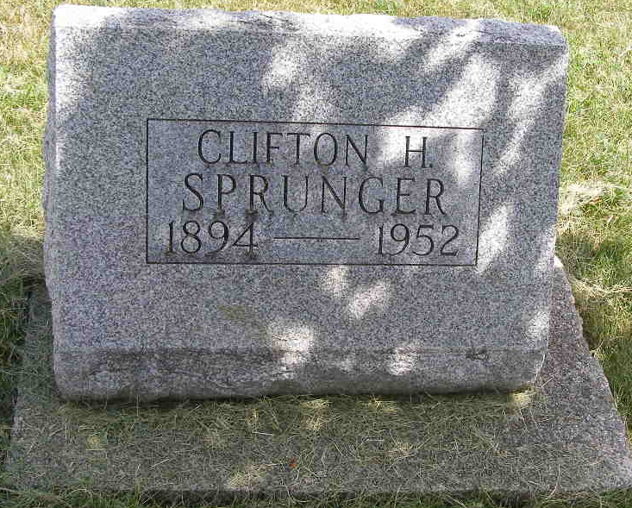
Photo by Shaunda Bedwell Opdycke

Handwritten-Wed. March 26, 1952
STORES TO BE CLOSED DURING C. H. SPRUNGER FUNERAL
E. W. Baumgartner, president of the Berne Chamber of Commerce asked today that all local stores and business places close for one hour on Thursday, from 2-3 p.m. during the funeral of Clifton H. Sprunger, president and general manager of the Berne Witness Company. Members of the Chamber of Commerce are asked to sit in a group in a special section of the church which will be reserved for the business men.
Adams County, Indiana Historical Museum
1951Nov-Apr1952 Scrapbook, Image 48
**
Indiana, U.S., Death Certificates, 1899-2017
Name Clifton E Sprunger
Gender Male
Race White
Marital Status Married
Age 58
Military WW I veteran
Birth Date 23 Feb 1894
Birth Place Berne, Indiana
Death Date 24 Mar 1952
Death Place Berne, Adams, Indiana, USA
Death Registration Date 1952
Father Jephtha F Sprunger
Mother Katherine Nussbaum
Informant Mrs. Clifton Sprunger
Burial 3/27/`952 M.R.E. Cemetery

