Clifford J. Sprunger
July 12, 1923 – October 26, 1980

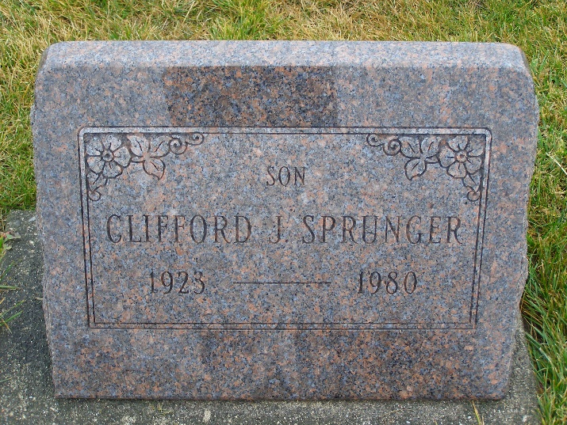
Photo by Shaunda Bedwell Opdycke

LOCAL SPORTS WRITER DIES SUNDAY
Clifford J. Sprunger, 57, died unexpectedly at 3:15 p.m. Sunday, Oct. 26, in the Ball memorial Hospital, Muncie. A lifelong resident of Adams County, he lived at 418 S. Linn Grove Ave., Berne. He worked as a fifth grade school teacher at Aboite Elementary School, Fort Wayne, and wrote South Adams sports for the Berne Tri-Weekly. He was a member of the Mt. Hope Nazarene Church, where he served as a church pianist and Sunday school teacher.
Born in Adams County on July 12, 1923, he was the son of Emil A. and Mathilda (Hirschy) Sprunger.
Survivors include: five sisters, Mrs. LaVere (Inez) Patterson, Mrs. Loris (Edith) Minger, and Mrs. Alton (Esther) Biberstein, all of Berne; Mrs. Francis (Minnie) Basinger, Bluffton, Ohio, and Miss Mariam Sprunger, Fort Wayne; and four brothers, Eli, Melvin, Tillman and Leroy Sprunger, all of Berne. Two brothers, Norman and Raymond, preceded him in death.
Funeral services will be conducted by Rev. Robert E. James at 10 a.m. Wednesday in the Mt. Hope Nazarene Church. Burial will follow in the M.R.E. Cemetery. Friends and relatives may call after 1:30 p.m. Tuesday at the Yager Funeral Home and from 9 a.m. until time of services Wednesday at the church.
Preferred memorials are to the Mt. Hope Nazarene Church.

Berne Witness, Adams County, Indiana
Monday, Oct. 27, 1980

