Clarence Homer Sprunger
January 21, 1897 – May 12, 1976

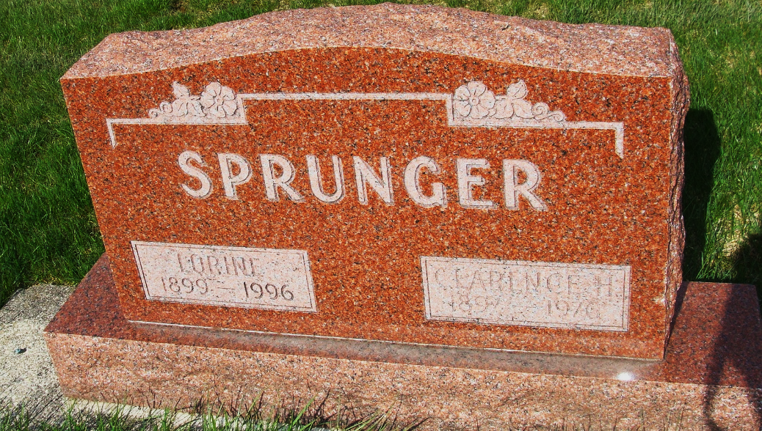
Photo by Alicia Kneuss

Clarence H. Sprunger, 79?? Of 217 West ??? Street in Berne, died at ?? p.m. at his home of a massive heart coronary. He was a retired mechanic and former ??? of the Jefferson garage.
Mr. Sprunger was a lifelong resident of Berne and was a charter member of the Berne Rotary Club, former president of the Berne Town Board two terms, former trustee at First Mennonite Church, and served on the board of directors of the First Bank of Berne for 41 years.
He was born in Berne to Daniel and Elizabeth (Lehman) Sprunger on January 21, 1897. He married Lorine Habegger on September 28, 1919.
Survivors in addition to the widow are four daughters; Mrs. Eli (Jean) Habegger, Berne; Mrs. Paul (Juanita) Herman, Berne; Mrs. Howard (Jacquline) Burnett, Anderson; Mrs. Samuel (Donna Mare) Sprunger, ???, Michigan; and two sons, Dilbert and Logan, both of Berne; 20 grandchildren, 14 great-grandchildren; one brother, Howard Sprunger, Berne; one sister, Mrs. Irvin (Agnes) Conrad, Toledo, Ohio; and one half-brother, Gilbert Stucky of Berne.
One brother, Herman Sprunger, and a half-sister, Mrs. Ira (Hulda) Sprunger, preceded in death.
Friends may call at the Yager Funeral Home in Berne after 4:00 p.m. today. Services will be held at the First Mennonite Church at 2:00 p.m. Friday with Rev. Vernon Sprunger officiating. Burial will be in the M.R.E. cemetery.
Preferred memorials are to Swiss Village, Inc. Children’s Bible Mission of Florida, or First Mennonite Church mission.
Berne (IN) Public Library Heritage Room
1973-1984 MRE Obit Book, image #115

