Clara (Nichols) Sprunger
August 30, 1902 – September 18, 1948

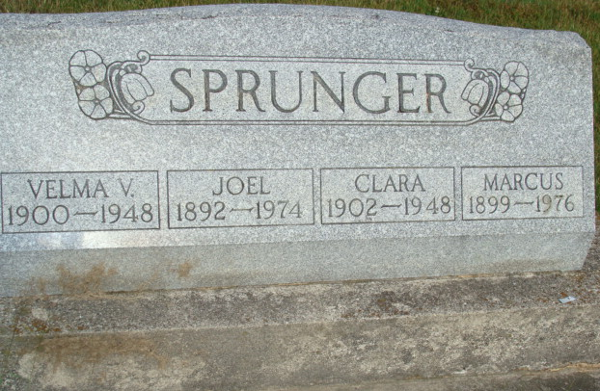
Photo by Alicia Kneuss
Indiana, U.S., Death Certificates, 1899-2017
Name Clara Michols Sprunger
[Clara Michols Nichols]
Gender Female
Race White
Marital Status Married
Age 46y Om 19d
Birth Date 30 Aug 1902
Birth Place Linn Grove, Indiana
Death Date 18 Sep 1948
Death Place Berne, Adams, Indiana, USA
Death Registration Date 1948
Father Forest Nichols
Mother Emma Yoder
Spouse Marcus Sprunger, age 47, informant
Burial 9-20-1948 M. R. E.

