Clara Mae (Steury) Sprunger
July 25, 1919 – May 6, 2010

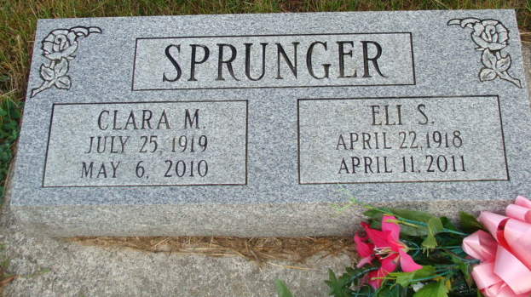
Photo by Alicia Kneuss

Clara M. Sprunger, 90, a resident of Berne, Indiana passed away at 3:35 a.m. Thursday, May 6, 2010 at the Adams Memorial Hospital in Decatur, Indiana. Clara was born on July 25, 1919 in Adams County, Indiana the daughter of David and Mary Steury. Her first husband, Wayne Matchett, passed away in 1944. She married Eli Sprunger on June 2, 1950 and he survives.
Clara was a member of the First Missionary Church in Berne. She was a member of the church choir, Christian Women’s Group, and was a volunteer at Swiss Village. Clara retired from C.T.S. Corporation with over fifteen years of service. She loved traveling, baking cookies, working in her garden, and caring for her flowers.
Clara is survived by her husband, Eli Sprunger of Berne; a son, Randall (Sarah) Sprunger of Berne, a daughter, Patricia (Evan) Liechty of Chardon, Ohio; a step daughter, Sharon (David) Cook of Decatur, Indiana; a brother, Clinton Steury of Fort Wayne, Indiana; a sister, Esther Stevens of Fort Wayne; a sister, Flo (Ernest) Fennig of Berne; and a sister, Shirley (John) Burke of Westminster, Colorado. Other survivors include seven grandchildren, six step-grandchildren, twelve great-grandchildren, thirteen step-great-grandchildren, and two step-great-great-grandchildren.
Clara was preceded in death by a brother, Dr. Ernest Steury; a brother, Frank Steury; a sister, Ruth Sprunger; a sister, Mary Alice Lehman; a grandson; and a great-grandson.
Funeral services will be held at 10:30 a.m. Monday, May 10, 2010 at the First Missionary Church in Berne with the Pastor Kris McPherson officiating. Interment will be in the M.R.E. Cemetery of rural Berne. Family and friends will be received from 2:00 – 8:00 p.m. Sunday, May 9, 2010 in the Swiss Village Chapel and one hour prior to the funeral service at the First Missionary Church on Monday.
Preferred memorials are to World Gospel Missions, Miracle Hill of South Carolina, or Family Hospice of Northeast Indiana.

Yager-Kirchhofer Funeral Home, Adams County Indiana

