Rev. Christian Sprunger
April 10, 1828 – October 18, 1903

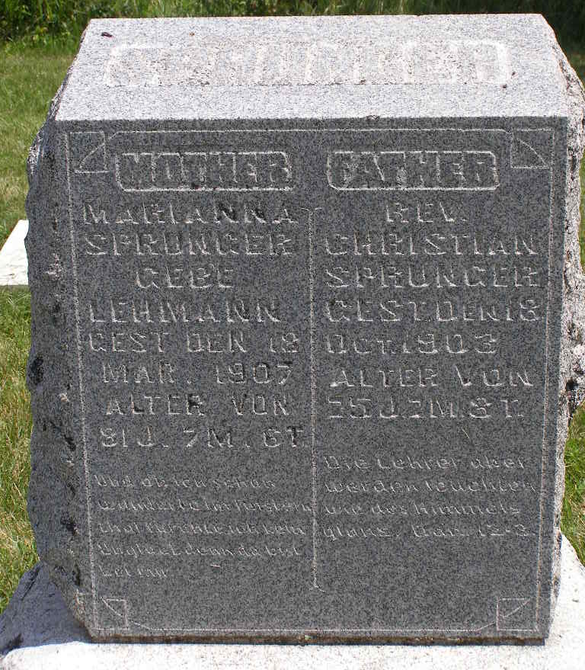
Photo by Shaunda Bedwell Opdycke

Ohio, U.S., Compiled Marriage Index, 1803-1900

Name Christian Sprunger
Gender Male
Spouse Marianna Lehman
Spouse Gender Female
Marriage Date 3 Jun 1852
County Wayne
State Ohio
**

U.S., Family History Books

Name Christian Sprunger
Gender Male
Birth Date 10 Apr 1828
Birth Place Latan Dachzfeldenberg, Switzerland
Marriage Date 3 Jun 1852
Spouse Marianna Lehman; Katharina
Children 15 listed
Title The Sprunger Family, 1757-1972: in Three Parts From Manuscripts, p. 21
5. Christian Sprunger, born April 10, 1828 on the Latan Dachzfeldenberg, Switzerland, married June 3, 1852 at Marianna Lehman, daughter of Peter Lehman. They came to America in 1852 and stayed a week in Wayne County, Ohio, then they came to Berne, Indiana. He became a Preacher of the Mennonite Church and was ordained in the spring of 1868.
Children
Katharina b. November 3, 1853 m. Peter A. Sprunger (2nd wife)
Marianna b. July 4, 1855 m. Samuel Steiner
Elisabeth b. March 29, 1857 m. Peter Beer
Joel b. August 17, 1858 m. Martha Lugenbuhl
Ulrich b. January 7, 1860 m. Anna Lichty
Christian b. October 26, 1861 d. January 12, 1865
Barbara b. March 30, 1863 m. Ezra Neuenschwander
Anna b. November 17, 1864 m. Abraham Beer
Giden b. September 6, 1866
Rosina b. January 27, 1869
Rachel b. September 6, 1871

