Christian C. Sprunger
September 11, 1860 – January 7, 1940

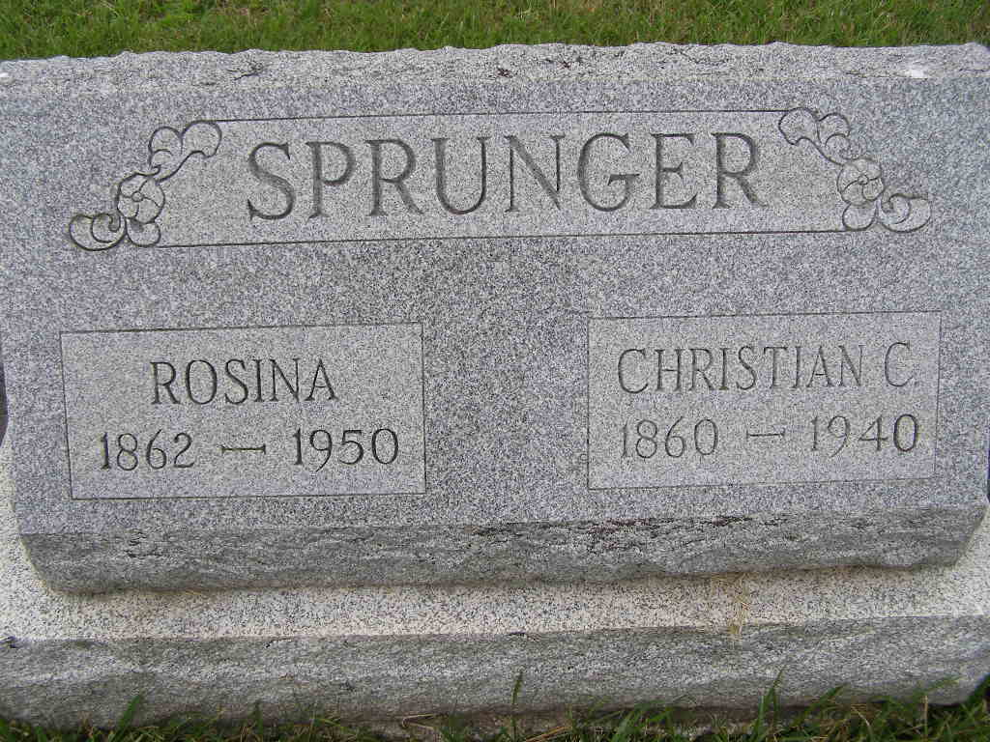
Photo by Shaunda Bedwell Opdycke

Berne, Jan. 7 - C. C. Sprunger, 79, retired farmer died late last night at his home here after an illness of one week. Surviving are the widow, Mrs. Rosina Sprunger; six sons, Victor Franklin and Wesley Sprunger of Berne, Oswald Sprunger of Fort Wayne, Asa Sprunger of Decatur, Illinois and Paul Sprunger of Milwaukee, Wisconsin; three daughters, Mrs. A. J. Neuenschwander of Quakertown, Pennsylvania, Mrs. Rena Zeurcher of Bluffton, Ohio and Mrs. M. A. Thomas of Union City; one brother, Benjamin Sprunger of Berne and two sisters, Mrs. Anna Liechty and Mrs. Marianna Stuckey of Berne.
Funeral services will be held Tuesday at 1:45 pm at the residence and at 2 pm at the Mennonite Church with Dr. C. H. Suckau officiating. Burial will be in M.R.E. Cemetery.

Journal-Gazette, Allen County, Indiana
January 8, 1940, Page 12
**

(Handwritten date: Monday, January 8, 1940)

C. C. SPRUNGER IS VICTIM OF STROKE SATURDAY
Funeral For Well Known Retired Farmer is Tuesday

C. C. Sprunger, 79, prominent retired farmer, died at his home on North Jefferson street Saturday at 10:50 p.m. following an illness of one week. Mr. Sprunger suffered a paralytic stroke last March but recovered and was able to be up and around and made frequent trips uptown. He suffered a second stroke Saturday, December 30, which left his whole side helpless. He grew weaker and weaker until death came.
Mr. and Mrs. Sprunger moved from their country home at the north edge of town to a property on Jefferson street which had been occupied by their son, Franklin Sprunger and family. The latter moved to the country home.
The decedent, interested in numerous business enterprises for many years, was a son of the late Peter and Marianna Moser Sprunger and was born on September 11, 1860, near Berne. On January 29, 1882, he was married to Miss Rosina Reusser, the vows being exchanged at the Mennonite church. He was a faithful member of the church from early boyhood.
Surviving are the widow, six sons and three daughters. They are: Oswald of Fort Wayne, Asa, of Decatur, Ill., Bessie, wife of the Rev. A. J. Neuenschwander of Quakertown, Pa., Wesley of Berne, Rena, wife of Noah Zuercher of Bluffton, Ohio, Franklin and Victor, of Berne, Paul of Milwaukee, Gertrude, wife of M. A. Thomas of Union City. One daughter, Ella, preceded. One brother, Benjamin, of this place and two sisters, Mrs. Anna Liechty and Mrs. Marianna Stucky, both of Berne, survive. Brothers preceding were Emanuel, Philip and Daniel. Mr. and Mrs. Sprunger celebrated their golden anniversary January 29, 1932 with a dinner and open house.
Funeral services will be held Tuesday at 1:45 p.m. at the residence and at 2:00 p.m. at the First Mennonite church. Dr. C. H. Suckau, pastor of the church, will officiate. Burial will be in the M.R.E. cemetery.

Adams County (IN) Historical Museum
1940 Feb-Dec Scrapbook, image 045-046

