Christian Sprunger
October 25, 1853 – December 18, 1856

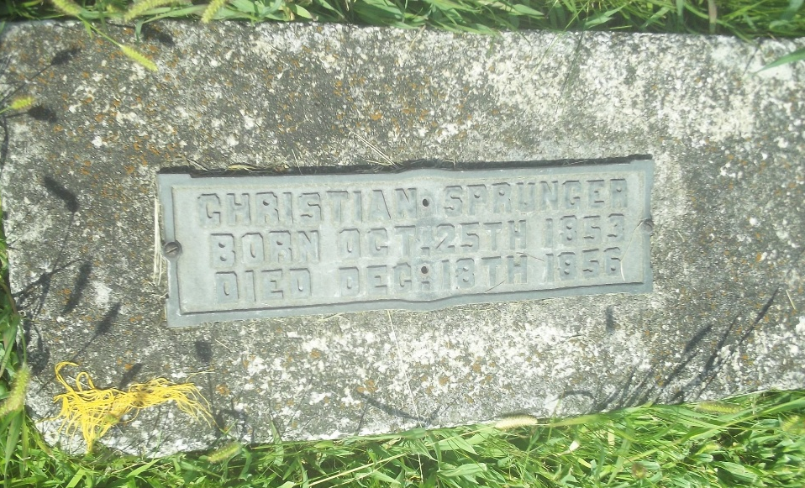
Photo by DSON1492

U.S., Family History Books
Name Christian
Birth Date 25 Oct 1853
Death Date 18 Dec 1856
Father Peter Sprunger
Mother Marianna Moser
Title The Sprunger Family, 1757-1972: in Three Parts From Manuscripts
p. 26
6. Peter Sprunger born January 28, 1825 on the Munsterberg, Switzerland, married November 29, 1851 to Marianna Moser. In 1852 they came to America to Adams County, Indiana. They bought a piece of woodland and built themselves a home where a part of the city of Berne now stands.
Children
Anna b. September 1, 1852 m. Emanuel J. Lichty
Christian b. October 25, 1853 d. December 18, 1856
Emanuel b. November 15, 1854 m. Katharina Stauffer
Daniel b. March 14, 1857
Phillip b. August 6, 1858 m. Anna Lehman
Christian b. September 11, 1860 m. Rosina Reusser
Marianna b. September 14, 1863 m. Daniel Stuckey
Peter b. November 20, 1867 d. December 3, 1869
Benjamin b. December 26, 1875

