Carrie Alpha (Badertscher) Sprunger
March 10, 1893 – September 11, 1982

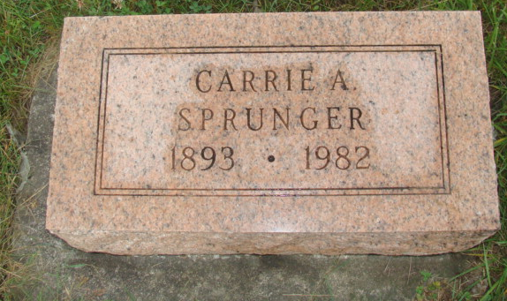
Photo by Alicia Kneuss

Indiana, U.S., Death Certificates, 1899-2017
Name Carrie A. Sprunger
[Carrie A. Badertscher]
Gender Female
Race White
Marital Status Widowed
Age 89
Birth Date 10 Mar 1893
Birth Place Ohio
Death Date 11 Sep 1982
Death Place Fort Wayne, Allen, Indiana, USA
Death Registration Date 1982
Father Christian Badertscher
Mother Leah Amstutz
Informant Royle L. Sprunger, son
Burial MRE Cemetery 9/13/1982

