Caroline (Scheidegger) Sprunger
February 11, 1879 – August 19, 1950

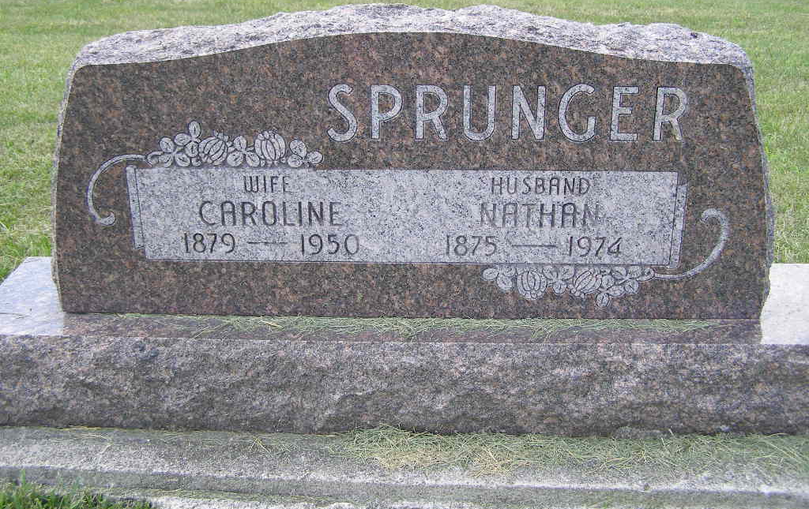
Photo by Shaunda Bedwell Opdycke
Indiana, U.S., Death Certificates, 1899-2017
Name Caroline Sprunger
[Caroline Scheidegger]
Gender Female
Race White
Marital Status Married
Age 71y 6m 8d
Birth Date 11 Feb 1879
Birth Place Adams Co Near Berne
Death Date 19 Aug 1950
Death Place Berne, Adams, Indiana, USA
Death Registration Date 1950
Father Christian Scheidegger
Mother Verena Sprunger
Informant Nathan Sprunger, Berne, IN
Burial 8-22-1950 M. R. E. Cemetery

