Caleb Sprunger
August 19, 1882 – June 29, 1955

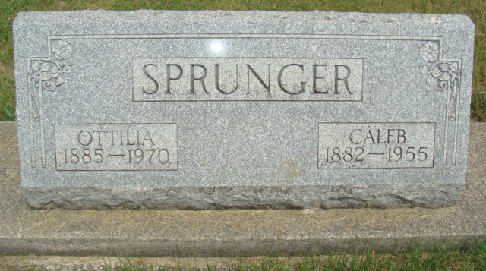
Photo by Alicia Kneuss

Handwritten date: Wednesday, June 29, 1955

STROKE FATAL TODAY TO CALEB SPRUNGER, 72
Services Here at 10:00 A.M. Saturday for Retired Farmer

Caleb Sprunger, 72, prominent retired farmer residing 1 ½ miles east of Berne, died at 8:30 a.m. today at his home, following a stroke he suffered last Friday. He had been in a critical condition since and in a coma most of the time. Mr. Sprunger had not been well for more than six months, being afflicted with a heart ailment. However, he had shown some improvement this spring and was able to be up and around part of the time until a few days before the fatal stroke.
A lifelong resident of this community, Mr. Sprunger was born August 19, 1882, in Monroe Township, the son of David and Regina Moser Sprunger. On Dec. 21, 1905, he was married to Otillia Sprunger. He was born on the same farm on which he died and lived there his entire life.
Surviving in addition to the widow are the following children: Mrs. Charles (Bernice) Bell, Fort Wayne; Mrs. Wilbur (Laura) Kirchhofer, Berne Route 2; Mrs. Sherman (Naomi) Von Gunten, Geneva Route 1; and David W. Sprunger, Berne Route 2; 17 grandchildren and the following brothers and sisters; Martin L. Sprunger, Berne; Mrs. Adella Sommer, Ft. Wayne; Mrs. Wilbert Nussbaum, Berne Route 1; two half-
sisters, Mrs. C.C. Moser, Fort Wayne and Mrs. Joel Lehman, Berne.
One grandson preceded in death. Also preceding in death were three sisters, Mrs. Frank Amstutz, Mrs. Ed. ​Baumgartner and Mrs. Adolph Sprunger; four half-brothers, Joshua, Isaac, Philemon and Amos Sprunger and three half-sisters, Mrs. Peter Schneck, Mrs. Ulrich Lehman and Mrs. Amos Burkhalter.
Mr. Sprunger was a member of the First Mennonite Church
and well known throughout the community.
Funeral services will be held at 10:00 a.m. Saturday at the
First Mennonite Church, Rev. O. A. Krehbiel officiating. Burial
will be in the M.R.E. Cemetery. The body is at the Yager
Funeral Home where friends may call after 6:00 p.m.
Thursday.

Adams County Historical Museum, Indiana
March 1955 – April 1958 Scrapbook, Image 17-18

