C. Eugene Sprunger
August 23, 1921 – December 2, 2003

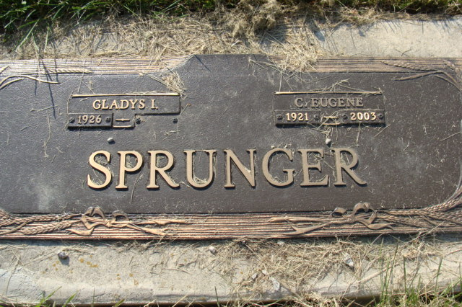
Photo by Alicia Kneuss

C. EUGENE SPRUNGER, 82, of Berne, died Tuesday, Dec. 2, 2003. Arrangements by Yager-Kirchhofer Funeral Home, Berne.

News-Sentinel, The (Allen County, Indiana)
Wednesday, December 3, 2003
**

Indiana, U.S., Death Certificates, 1899-2017

Name C Eugene Sprunger
Gender Male
Race White
Marital Status Married
Age 82
Birth Date 23 Aug 1921
Birth Place Adams County
Death Date 2 Dec 2003
Death Place Berne, Adams, Indiana, USA
Death Registration Date 2003
Father Robert Sprunger
Mother Rhoda Liechty
Spouse Gladys (Zimmerman) Sprunger
Informant Deb Martens, daughter
Burial 12/5/2003 M.R.E.

