Betty Jean (Riesen) Sprunger
October 4, 1926 – August 18, 2007

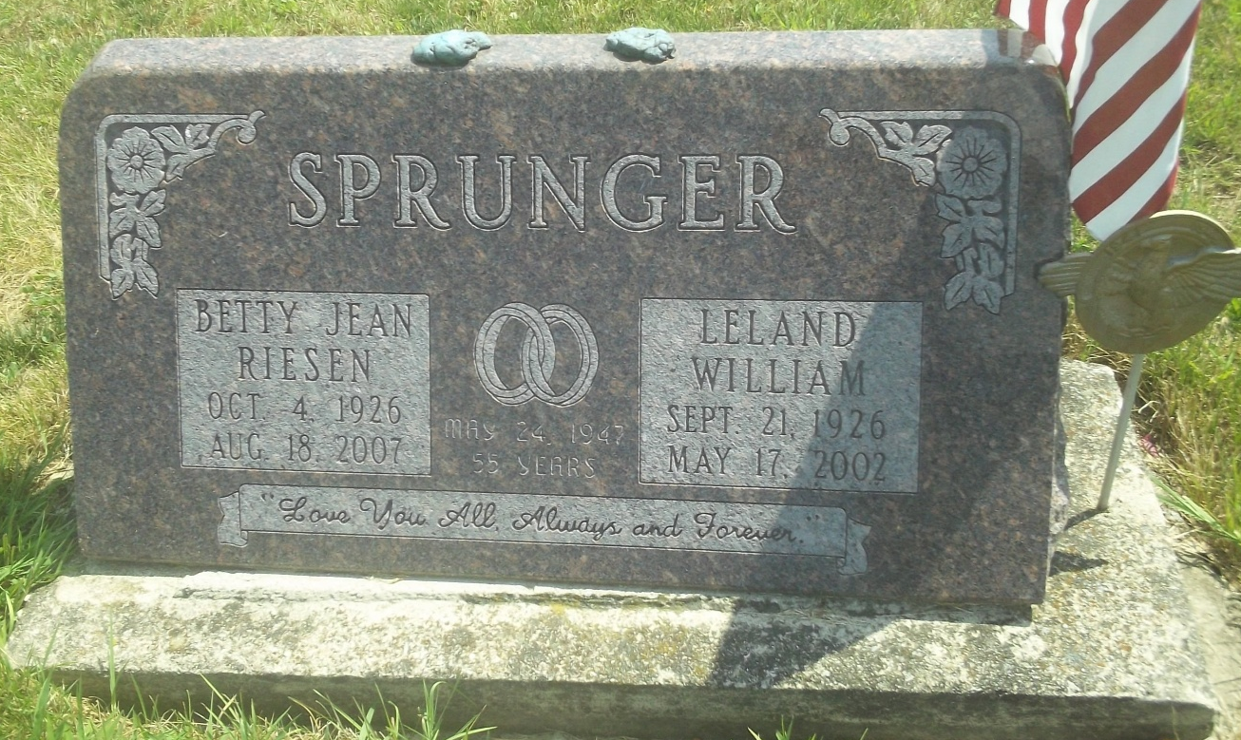
Photo by DSON1492

Betty Jean (Riesen) Sprunger, 80, of Warminster, Pennsylvania, passed away Saturday, August 18, 2007 in the Doylestown Hospital in Doylestown, Pennsylvania. Betty was born on October 4, 1926 in Geneva, Indiana, the daughter of the late Gideon E. Riesen and the late Viola L. (Baker) Riesen. She was married the late Leland W. Sprunger for 55 years.
Betty was a graduate of Northside High School Class of 1944 in Fort Wayne, Indiana. She retired from sales at J. C. Penney and the Thrift Drug Company. Betty was also a homemaker.
Surviving are her son, Arthur Lee Sprunger of Pennsylvania; son, Timothy Ray Sprunger of Florida; daughter, Elaine Kay Sprunger Raisner of Pennsylvania; daughter, Victoria Sue Sprunger Butchar of Florida; sister, Maxine Reisen Walling of Ft. Wayne, Indiana; grandchildren: Joshua Sprunger of Pennsylvania; Stephen Raisner of Pennsylvania; Jana Raisner of Pennsylvania; and Matthew Butchar of Florida.
Funeral services will be held at 11:00 a.m. Friday, August 24, 2007 in the Yager Kirchhofer Funeral Home, Berne, Indiana with one hour of visitation before the service at the funeral home. Burial will be in the M.R.E. Cemetery of rural Berne, Indiana. Preferred memorials are to the LVPA Skate for Hope (Cancer Benefit) at P.O. Box 2853, Warminster, PA 18974.

Yager-Kirchhofer Funeral Home, Adams County, Indiana

