Berniece Lucile (Nussbaum) Sprunger
June 25, 1924 – October 2, 2005

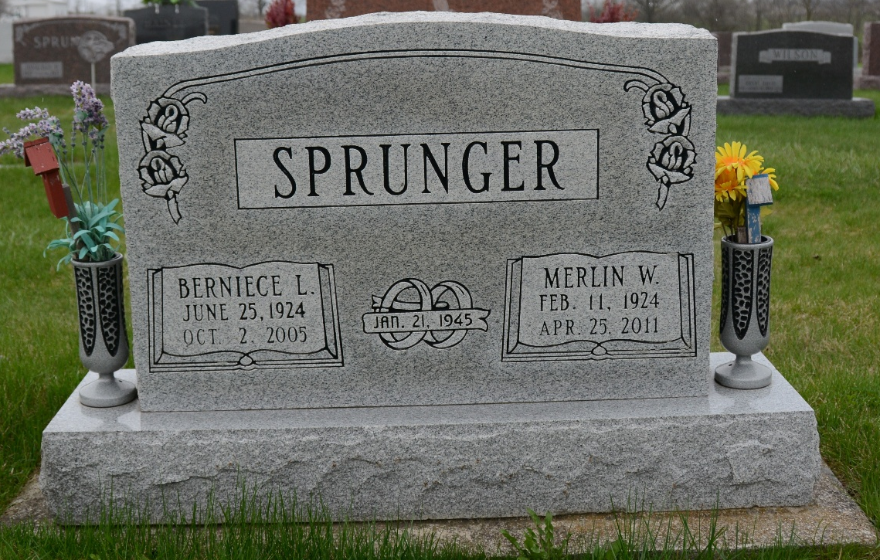
Photo by Deb Curry

BERNIECE L. SPRUNGER, 81, of Berne, died Sunday, Oct. 2, 2005, 10:05 a.m., at Adams Memorial Hospital. She was employed at Sprunger Shoe Store, for over 40 years and was a member of First Mennonite Church, Berne. Survived by husband, Merlin W.; children, Charlotte (Fred) Linn, Ryan Sprunger and Nancy Smith, all of Berne and Sharon (Tom) Ninde of Geneva; four sisters; and six grandchildren.
Service is 10:30 a.m. Wednesday at First Mennonite Church., with calling one hour prior to service. Calling is also from 1 to 8 p.m. Tuesday at Yager-Kirchhofer Funeral Home, Berne. Burial at M.R.E. Cemetery. Memorials to Mennonite Disaster Service or Gideons International.

News-Sentinel, The (Allen County, Indiana)
Monday, October 3, 2005

