Benjamin Sprunger
December 26, 1875 – September 6, 1974

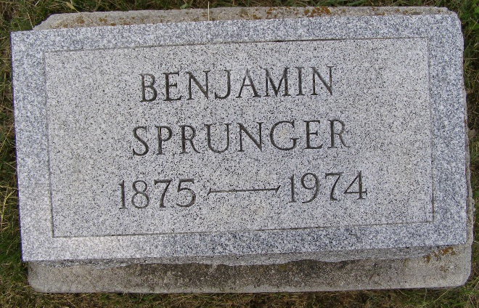
Photo by Shaunda Bedwell Opdycke

Rites Here Today For Benjamin Sprunger, Longtime Businessman

Services were held at 10 a.m. today in the Chapel of the First Mennonite Church for Benjamin Sprunger, 98, who died at Swiss Village at 7:10 p.m. Friday following an illness of two weeks. He had been in failing health several years. Mr. Sprunger was the second elderly resident of Swiss Village to die within a few days. Nathan Sprunger, 99, the area’s oldest resident, died August 29.
Rev. Kenneth Bauman, pastor of the First Mennonite church of which Mr. Sprunger was a member, officiated at the service and burial was in the M.R.E. cemetery.
Long a businessman in Berne, Mr. Sprunger was a lifelong resident of this community. He operated the Sprunger Shoe Store for many years, retiring in 1965. He was a president of the Berne Lumber Company for a number of years and was active in business civic and church events. His father was one of original founders of Berne. Mr. Sprunger taught a Sunday School class in the Mennonite church for over 50 years and served as a deacon in the church many years.
Born in Berne December 26, 1875, Mr. Sprunger was a son of Peter and Marianna Moser Sprunger. He was married to Susanna Burkhalter who died in 1928. On Nov. 23, 1930, he married Amanda Egly who survives. Mr. and Mrs. Sprunger resided on North Jefferson street for many years and moved to Swiss Village several years ago.
Surviving in addition to the wife are two grandchildren and six great-grandchildren. A son, Edison Sprunger died in 1942.
The Yager Funeral home had charge of the service.

Date of Death: Sept. 6, 1974; Date of Burial: Sept. 9, 1974

Berne (IN) Library Heritage Room
1973-1984 MRE Obit Book, image #64
**

Benjamin Sprunger dies at age of 98

Benjamin Sprunger,98, of Berne, the last surviving member of his family, died at 7:10 p.m. Friday at Swill Village. He had been bedfast two weeks.
Mr. Sprunger was a former president of the Berne Lumber Co. and operated a shoe store in that community before retiring in 1955. He was a member of the First Mennonite Church, where he taught Sunday School for over 50 years.
He was born in Berne on Dec. 26, 1875, the son of Peter and Marianna Moser-Sprunger, and was married on Nov. 23, 1930, to Amanda Egly, who survives. Other survivors include two grandchildren and six great-grandchildren. One son, two sisters and six brothers preceded him in death.
Mr. Sprunger’s father was one of the founders of Berne.
Funeral services will be held Monday at 10 a.m. at the First Mennonite Church chapel, with Rev. Kenneth Bauman officiating. Burial will be in the MRE cemetery. Friends may call at the Yager funeral home after 11 a.m. Sunday.
Decatur Daily Democrat, Adams County, Indiana
Saturday, Sept. 7, 1974

