Beatrice Eula (Douglas) Sprunger
August 31, 1923 – September 4, 1997
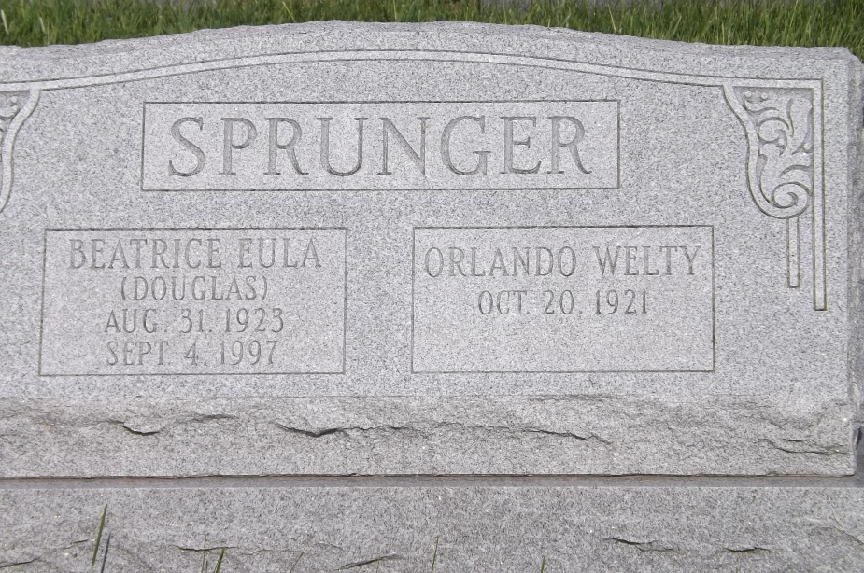
Photo by Jim Allen

Indiana, U.S., Death Certificates, 1899-2017

Name B. Eula Sprunger
Gender Female
Race White
Marital Status Married
Age 74
Birth Date 31 Aug 1923
Birth Place Allen County, Indiana
Death Date 4 Sep 1997
Death Place Berne, Adams, Indiana, USA
Death Registration Date 1997
Father Lester Douglas
Mother Mae Presdorf
Spouse Orlando W. Sprunger, informant
Disposition 9/8/1997 Northern Indiana Crematory Corp.
**

Beatrice Eula Douglas from tree SPRUNGER

Birth 31 Aug 1923 Allen, Indiana, USA
Marriage 30 Aug 1946 Allen, Indiana, USA
Residence 1950 Berne, Adams, Indiana, USA
Death 4 Sep 1997 Berne, Adams, Indiana, USA
Father Lester L Douglas (Born 1903)
Mother Ella M Presdorf (Born 1902)
Spouse Orlando Welty Sprunger (1921-2022)
12073 People 5 Records 5 Sources

